Teaching Spanish Culture Online: Strategies and Solutions for Active Learning & Social and Emotional Learning
Enrique Mallen

1. Introduction.
For many years, I had been looking for ways of teaching that would engage students creatively and emotionally in their learning outcome. With Active Learning and SEL I have found a way to accomplish precisely that. Here I will be discussing some of my experiences as an instructor in the Pablo Picasso and Spanish Art (SPAN 4365) course, which I regularly teach on campus. My courses focus primarily on visual culture, particularly as it pertains to Spanish history and civilization. Visual culture refers to the tangible, or visible, expressions by a people, a state or a civilization, and collectively describes the characteristics of that body as a whole (cf. Whitney 2018). The term is most useful for what specific aspects of the visual culture of a people reveal about themselves. I have already presented some of these findings at the Digital Education Summit 21, the 17th Annual Diversity Leadership Conference, the Digital Education Summit 20, the Teaching & Learning Conference 2020 and the Universality of Global Education Conference.

2. Active Learning and Visual Culture.
Visual culture is currently booming throughout the world. Literature now competes with visually encoded practices such as digital imaging, film, TV, photography, painting, etc. to capture the public’s interest. The emergence of the field of study known as Visual Culture has been posited as a symptom of, and a response to the image-based contemporary cultural landscape. Mitchell (2015) discerns a clear transition from the linguistic to the visual turn, a rediscovery of the picture as a complex interplay between “visuality” and “figurality”. For this reason, it is important to educate our students in this area. He points out how visual experience may be as deep a problem to interpret and address as various forms of reading. And yet, visual literacy might not be fully explicable on the model of textuality. Due, in part, to the “linguistic turn” that has dominated critical debate and to its reduction of visual images as to readerly paradigms of analysis, the visuality of culture was for a period misinterpreted and even ignored (cf. Waterton & Watson 2016). Recently, however, the problem of pictorial representation has become inescapable, gaining unprecedented force on every level of culture.
Another recent change in our approach to culture involves the internet, which is quickly revolutionizing information and communication on a global scale by overcoming boundaries of space and time (cf. Nakamura 2008). Those who are most responsible for a positive impact and revolutionary innovations are educators in major institutions (cf. Linden 2016). In this light, the global academic repercussions of innovative projects are immense. Technological developments undoubtedly offer further assistance in educating the general public.
As is the case with the introduction of new technologies around the world, there are always beneficial repercussions when change occurs. The internet, a relatively new feature of global culture, is an example of technological change at its best. In a short period of time, people of all ages and levels across the globe have become accustomed to living with it as a new medium for information exchange. The greatest promise the internet has to offer the art community is in the dissemination of art to the general public at a low cost and a faster pace. Scholars are in a position to educate a large number of people by spreading their knowledge through the internet. When knowledge is dispersed freely it can be checked, verified, contested, adapted, and—ideally —put to good use. By presenting information richly laden with visual and interactive elements, a wider audience can be attracted.
Throughout the years, I have taught SPAN 4365 from multiple angles. While I always engaged my students in class activities and required presentations and group projects, the course has progressively moved from being lecture-oriented to a primarily project-oriented approach. I have noticed firsthand how students’ outcome have improved with more Active Learning. They not only got a better experience from their class participation, but the knowledge they gained had a transformative impact in their lives. For that reason, all of the designed student projects aim to achieve productive learning. Most recently, and due to the pandemic, I taught this class online for the first time, which presented new challenges and opportunities.
In this global overview of Spanish art and culture, I had my students take an active role, participating in shaping the pedagogical experience, creating individual and group projects and requiring several in-class presentations. As I told them, Active Learning means shifting some of the leadership of the course from instructor to students, and creating a situation where all participants are responsible, in a significant measure, for their own learning. The final goal, as I explained to them, is to change from focusing on the mastery of content, and the mere attainment of a grade, to helping them prepare for life and successful work after graduation.
As Albert Einstein famously noted, “Education is not the learning of facts, but teaching the mind to think” (cf. Frank 2002). Now that technology has made it easy to find any sort of fact in a matter of seconds, the ability to regurgitate information is no longer valued the way it once was. In a 2015 survey conducted by the National Association of Colleges and Employers, employers listed the skills they valued the most in new hires. Among the top 10 were qualities like the ability to work as a team and problem-solving skills. Both of these are actively promoted in project-oriented learning.
I made sure that students in my online class were involved in Active Learning throughout the semester, taking the role of participants in the learning process. One essential aspect of Active Learning is the incorporation of numerous activities in which students personally engage with the material. For that purpose, I encouraged Social and Emotional Learning (SEL) in my class. It has been demonstrated that once students get personally involved in the material, they tend to learn better and retain more. With that in mind, students were given assignments that included creative and self-reflective activities conducive to productive online learning.

3. Social and Emotional Learning (SEL).
A new emphasis in education focuses on SEL, the process through which learners acquire and effectively apply the knowledge, attitudes, and skills necessary to understand and manage emotions, feel empathy for others and set and achieve positive goals.
It jas been demonstrated that SEL plays a key role in academic readiness and success. Students with strong SEL skills participate more in the classroom, have more positive attitudes about and involvement with school, and are more accepted by classmates. Without SEL skills, students are more likely to dislike class activities and perform poorly on academic tasks, and later experience grade retention and dropout (cf. Raver & Knitzer 2002).
Up through high school, SEL skills in students are organized around “positive engagement” with teachers and the environment, managing emotions within controlled social interactions, remaining connected with adults as they successfully relate to their peers. By the time they enter college, students are expected to form closer relationships with classmates, successfully negotiate within a larger peer group, come to understand the perspectives of others, gain emotional independence, establish an ethical and moral system, and achieve socially responsible behavior. The interpersonal domain of SEL includes teamwork, collaboration, and leadership; while the intrapersonal domain comprises intellectual openness, ethics, and positive self-evaluation.
In a recent study, students who participated in SEL programs scored 13 points higher academically and were 11 percent more likely to graduate from college. Taking this into consideration, students in the course: (1) analyzed the content of works by Spanish artists; (2) evaluated how their circumstances influenced both subject matter and style, and reflected on how they may react to the same circumstances today; (3) created works of their own that somehow emulated other Spanish artists.

4. Pablo Picasso and Spanish Culture.
Pablo Picasso and Spanish Art (SPAN 4365) is centered around Pablo Picasso, a great artist to explore Spanish history and culture of the 20th century and beyond. The purpose of the course is to introduce students to the culture and civilization of Spain, using primarily visual material. We live in a world where visual content is constructed and redefined as society develops. Visual culture is a living art form that constantly changes before our eyes and has power over us. This makes teaching visual culture all the more relevant. It is important to teach students to carefully look at and examine the ideas presented in images. Practicing this skill makes them more discerning visual consumers. However, “true seeing” takes practice. As Jenks (2005) has pointed out, “looking, seeing, and knowing have become perilously intertwined.” It is easy to make assumptions that are based on imprecise visual interpretation.
A variety of topics relevant to Spanish art history in the context of other European nations are discussed. A discussion of Picasso’s art serves as a great platform to get students involved in the culture of the period and the circumstances surrounding it. As Unger (2018) has stated, “the fractured mirror the artist held up reflected an image of our time as harrowing as it was exhilarating.” Picasso is one of the most autobiographical painters. His works reflect no only his deep roots in Spanish culture, but the major events that took place in the nine decades he lived: World War I, the Spanish Civil War, World War II, the Cold War, etc. Although these occurred way before most of our students were born, they relate to these historical conditions through similar circumstances we are experiencing in the present time: conflict in the Middle East, terrorist attacks, social and political crises, etc.
During the course design, I made sure I covered all cognitive levels in the learning process: (1) Remembering. At the end of the class students were able to recognize relevant art historical facts and itemize them in concise form. They practiced recognizing or identifying information in interactive discussions. (2) Understanding. Students were able to interpret terminology in art history and determine their validity. They restated or paraphrased and summarized information or knowledge in directed discussions. (3) Applying. Students were able to implement problem-solving skills by finding patterns in artistic compositions. They followed procedures, principles, rules, and steps for using or applying the material provided in class in their presentations. (4) Analyzing. Students were able to distinguish between different art historical terms, and classify concepts, examples, or phenomena into correct categories. (5). Evaluating. Students were able to self-reflect on the causes that triggered works of art, and draw inferences from observations, making predictions from the information provided. In this area we implemented student-peer feedback. (6) Creating. Students were able to create their own work as a reaction to the analyzed context, mounting exhibitions or creating collage that emulated the work of Picasso. This component strictly involved project-based learning.
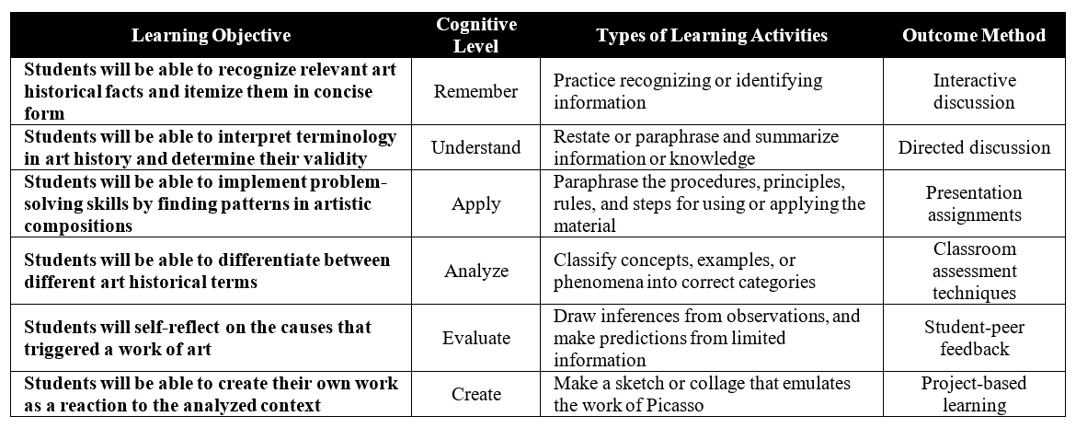

5. Active Learning Techniques.
In the next pages I will go over one of the Active Learning and SEL techniques that I used in my SPAN 4365 course, namely the Jigsaw Activity. The main goal was to promote interdependence in class, along with an emotional involvement in the lesson discussed. Here I will use the section of the course schedule in which we discussed the painting Guernica, a major canvas by Picasso that is symbolic of a whole period of his artistic career.
The lesson was divided into six segments, assigning each to a different group of student who became “experts” in one of those segments covering (1) Historical facts; (2) Biographical facts; (3) Cultural facts; (4) Mythology; (5) Art history; and (6) Formal art components. I first made sure that each group had an overall understanding of the material that had been assigned to them and my expectations for the activity. A representative from each group introduced their segment while other students listened, asked questions and made “sketchnotes” of their reflections. This was followed by a group discussion period involving everyone in the class; as well as by individual projects. My primary role in this and other activities was to serve as a facilitator and guide, fostering independent, critical and creative thinking in my students. At all times, I encouraged active collaboration in the class through group activities, thus transforming students from passive listeners to interactive participants.

6. A Brief Introduction To Guernica As History Painting.
According to Belton (1996), paintings may be divided into five genres: (1) History Painting, with factual, religious or allegorical content possibly linked to a moral message; (2) Portrait Art, depicting individuals or groups; (3) Genre Painting, illustrating scenes of everyday life; (4) Landscape Painting, whose principal content is a scenic view; and (5) Still Life Painting, showing an arrangement of domestic objects or everyday items. The mural Guernica, painted by Picasso in 1937, may be classified in the first genre of History Painting, which in turn has five subcategories: (1) Religious history paintings involving any type of picture with a religious narrative; (2) Mythological history paintings in which stories are developed to explain certain phenomena in the world; (3) Allegorical history paintings which contain hidden meanings, using people or objects that symbolize other people or things; (4) Literary history paintings that consist of narratives based on literary themes; and (5) Factual history paintings that depict an event or a moment in history. Interestingly, Guernica has elements of all five subcategories within the genre of History Painting.
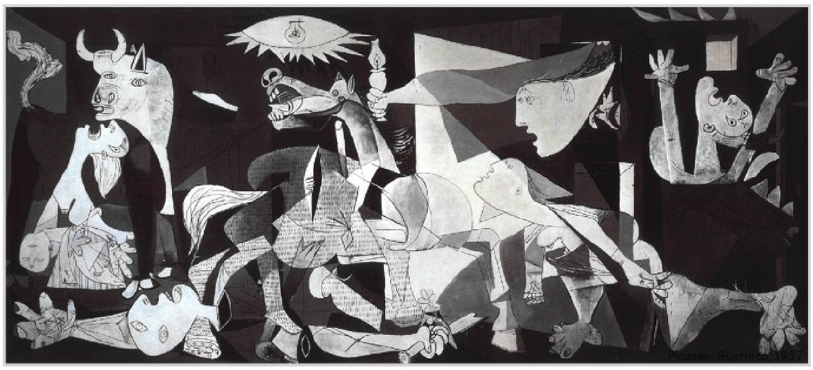
ANALYSIS OF GUERNICA
Pablo Picasso. Guernica. 1937
Pablo Picasso. Guernica. 1937

The horizontal-format composition of Guernica consists of seven groups clearly, yet subtly, divided up. High in the middle of the picture an ambivalent motif, a large “eye of God,” surrounded by a circlet of irregular jags, with a light bulb for a pupil; beneath it, a gaunt shrieking horse staggers with the stump of a lance pierced through its back, the point emerging from its side; under the hoofs lies the body of a man, shattered as a marble statue, with clean breaks at the neck, one arm stretching to the left-hand edge of the picture, the other grasping a broken sword, as it touches a little growing flower. To the right, from a square space, are a stylized human head in profile and an arm holding a lighted oil lamp over the scene, reaching almost to the horse’s head and lighting up not the house from which she leans but a single sharply-defined area, the horse’s chest and the upper part of another woman, hurrying towards the center, her pose plainly conceived to fit the falling diagonal, her trailing leg with its huge knee and foot extending to the right lower end of the picture. A counterpart to this figure is the warrior statue on the ground to the left below the horse. From the darkness to the left of the horse, but on another plane, the dangerous head, shoulders, and one leg of a great bull emerge into the light, while below the bull and to the left, a woman screams, holding her dead child in her arms. A corresponding female at the right edge of the canvas is trapped in burning wreckage with her white arms stretched up and her white head flung back in the same atrocious agony. The dark-light contrasts heighten this unsettling effect of destabilization, since no definite source of light can be made out. After the first shock, however, one sees that order underlies the apparent chaos and that, although at a casual glance the picture might seem to be a polyptych made up of panels containing the bull, then the horse, the woman with the lamp, and lastly the woman trapped, the whole is in fact bound together by a broad-based triangle formed by drawn lines and the superimposition of planes, and reaching its apex just above the central lamp, with less obvious answering diagonals rising from near the base to the outer edges.

7. “Expert”-Led Segment Discussion.
In this section I will briefly go over the six segments that the student group discussed in class as led by a peer-selected “expert.”

7.1. Historical Facts.
Guernica was painted in the context of the Spanish Civil War. On July 17, 1936 spurred to action by the assassination of the conservative leader Calvo Sotelo, a cadre of right-wing military officers initiated a military uprising (Pronunciamento), led by General Mola, General Francisco Franco and General José Sanjurjo. The move had been intended to immediately seize power, but successful resistance by elected Republicans in Madrid, Barcelona, Valencia and the Basque country meant that Spain was in the end condemned to a prolonged civil war.
As the war progressed and following a request from Francisco Franco, the little town of Guernica in the Basque country was bombed on April 26, 1937 for three consecutive hours by the German Legión Condor assisted by a small Italian bomber escort. This was market day, and the main square and surrounding streets were crowded. The front was less than twenty miles away, but there was no target of military importance in the town. After a first wave of Heinkel 111s came in, strafing and bombing, followed at twenty-minute intervals by waves of Junker 52s, dropping incendiaries. Screaming with terror, people fled the burning town, but the planes followed them into the fields, mowing them down. Bombs kept pounding Guernica throughout the day, leveling its center, killing 1,654, wounding 889. Ostensibly, the goal had been to cut off the escape route of the retreating Basque troops, specifically the bridge at the northern end of the town which had been designated as a “strategic military target,” but ironically it never was hit.
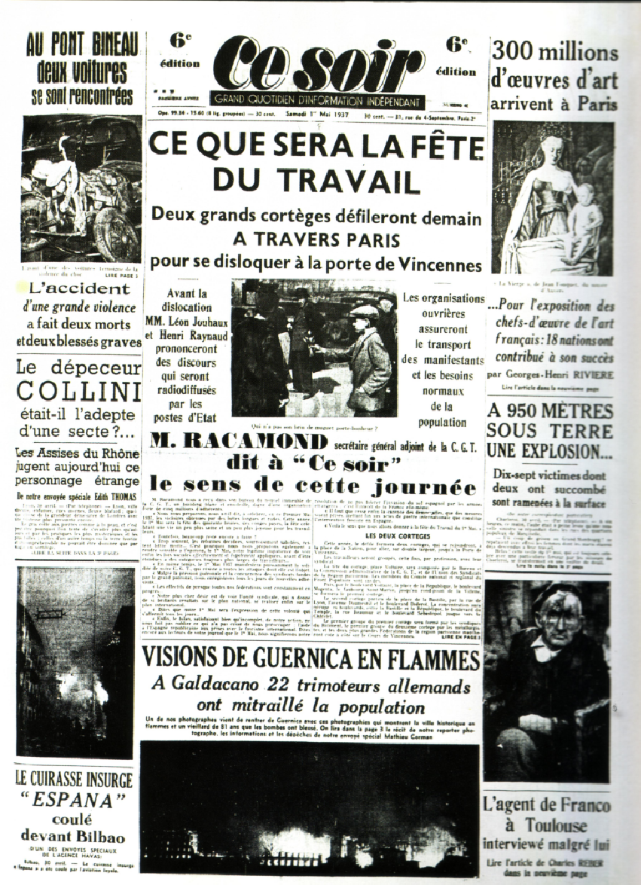
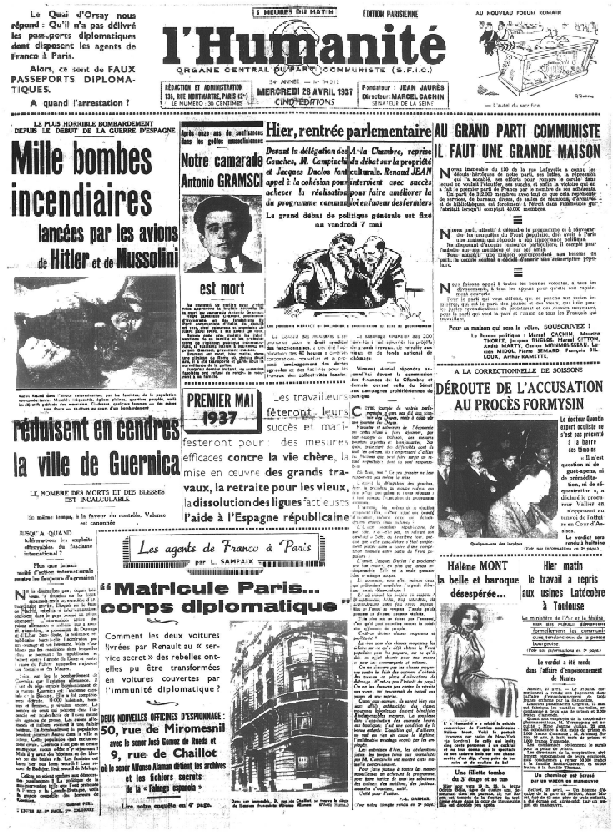

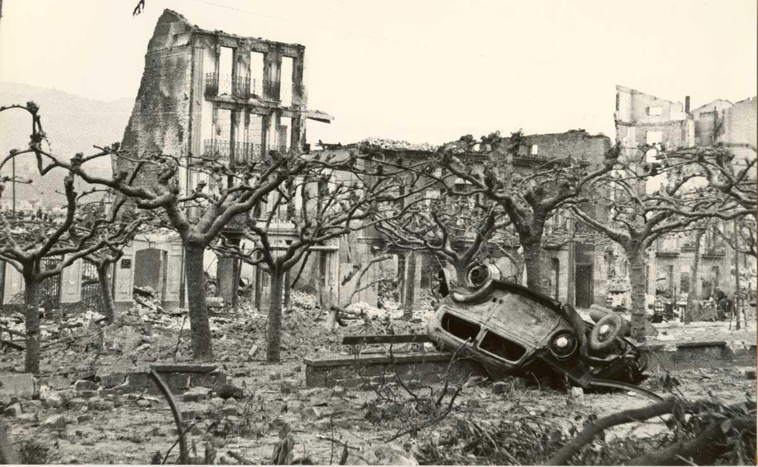

7.2 Biographical Facts.
At the time of the attack Picasso was living in Paris, although he got news of the bombing almost immediately through the French press. The first newspaper account in Paris appeared on the same evening in Ce Soir, the month-old paper supportive of the Spanish Republic and edited by Picasso’s friend, Louis Aragon. One day later, the Communist newspaper L’Humanité published photographs of dead women and children killed during the attack to Guernica with the headlines “A thousand incendiary bombs dropped by the planes of Hitler and Mussolini reducing the city of Guernica to cinders.”
To examine the intricacies of Picasso’s biography for our study of this and other periods of the painter’s career, we made use of the extensive documentation available on the Online Picasso Project (OPP), which has been in operation since 1997. using multiple computer applications and a large set of interrelated databases that allow us to link a wide range of different types of cultural and art-historical information pertaining to the Spanish artist’s career. In its half-a-century of operation, OPP has become the largest digital repository of documents on the legacy of this renowned Spanish artist.

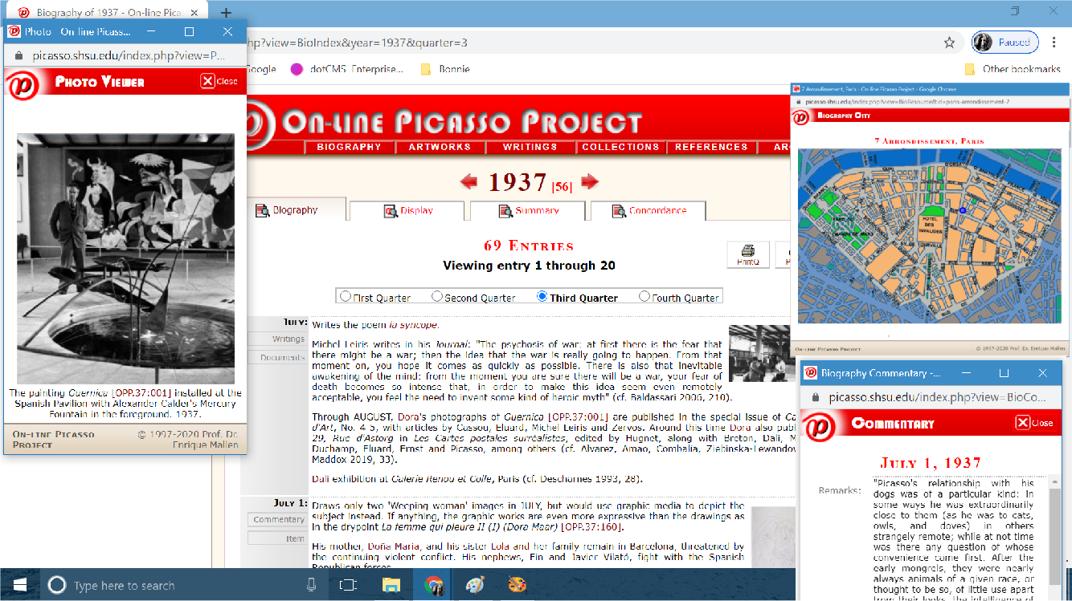

The Online Picasso Project now contains over 35,000 artworks and an equal number of notes, commentaries, bibliographical references and archived article. At this time storage, structure, presentation, and transformation have been separated, allowing more flexibility in maintaining and accessing the on-line catalog. This has been accomplished by using MySql to store the information, XML-structured query results from servlets, cascade style sheets to format the results, and javascripts to manipulate the generated pages. To give an idea of the complexity in maintaining the Picasso Project databases, we have to consider the fact that artworks are linked to both a narrative of historical events—divided into time spans—in the artist’s life and to critical essays. Within the narrative, references are made to places where the artist lived or worked at any given time, providing maps and photographic images of those places. Additionally, references to people the artist was in contact with at that time are also given, along with photographic illustrations.
7.3. Cultural Facts.
The bullfight in Spanish culture: a brutal and gory confrontation. The bullfight sets up several men (mostly on foot, but one of them riding a horse) against a bull in an enclosed ring. It is not uncommon for both horses and men to be injured or killed the corrida. Bullfighting can be traced back to ancient days, as it was a popular spectacle in ancient Rome. But it was in the Iberian Peninsula that this ritualistic encounter between man and animal was fully developed.

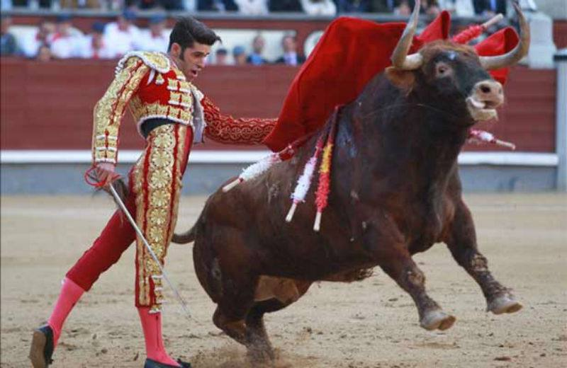
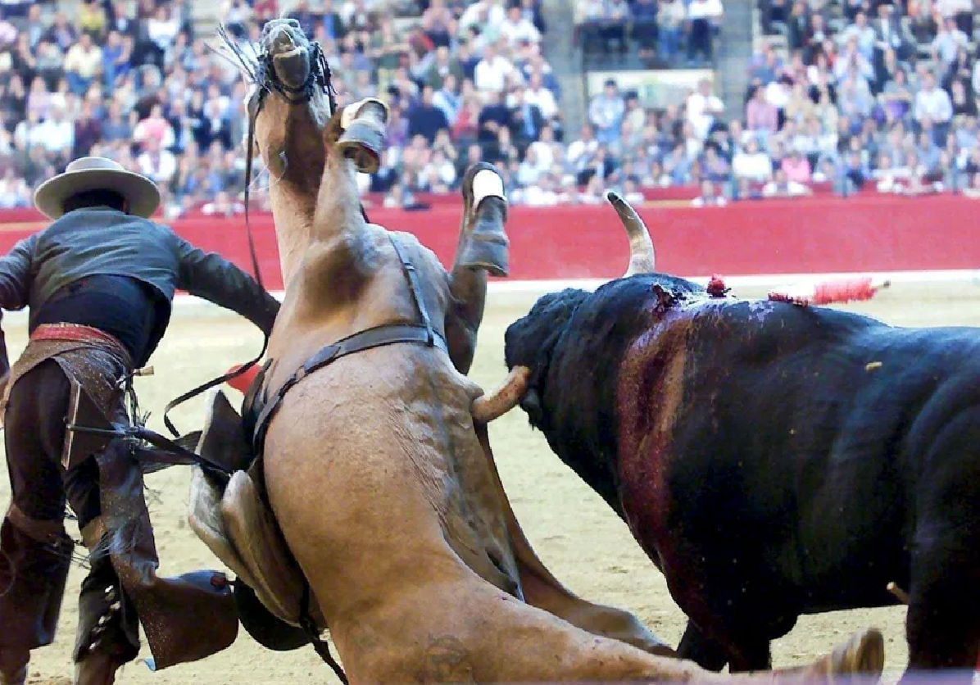

At first Spanish nobles clubbed together and used the corrida to train horses. The horse had to remain surefooted and his noble rider calm as they showed off their bravery and skill by riding circles around the bull. Servants were on standby on the sides to distract the bull when things became too dangerous. No doubt the servants waved around their hats or capes to catch the bull’s attention when necessary. After bullfights were banned in the 18th century as being unsuitable for the nobility, regular people on foot maintained the tradition and now became the main attraction. Waving around their cape developed eventually into a system of stylized passes. Picasso concentrated on two aspects of the corrida: the picador (where a man on a horse confronts the bull with a lance) and the matador (who is the one that often kills the bull). The corrida continues to be a strong component of Spanish culture, even for those who have never attended one.

7.4. Mythology.
The figure of the bull that is featured in both the bullfight and Guernica is closely related to another frequent character in Picasso’s repertoire, namely the Minotaur. Among the works in which the artist examined him is his 1935 etching La Minotauromachie, a term he invented to unite two of his favored themes: the half-man, half-bull creature of Greek mythological and the bullfight. Through highly personal themes and motifs, Picasso forged a multilayered, universal allegory of violence vs. innocence, suffering vs. salvation. Two years later, he would adopt much of the its imagery for his mural painting Guernica, his outraged response to the Spanish Civil War.
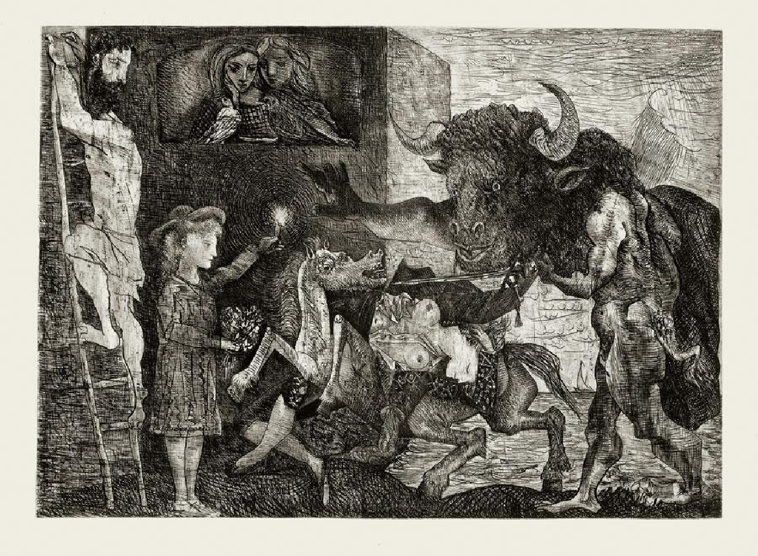

La Minotauromachie. 1935

The etching includes other motifs he had already dealt with in several media in the early 1930s: the gored horse, a wounded or dead female torero, a girl with a lit candle, a man on a ladder, etc. In his depiction, heroes are no longer absolute characters, but rather must accept their ambiguous mixture of good and evil. For instance, the woman with the light is the source of light that emanates from the candle she is holding, but she is not without shadow for she impassively witnesses the tragedy. The disembodied horse and the collapsed female matador whom it carries symbolize victims, yet they are not portrayed as entirely innocent: the expiring female is simultaneously an executioner for she turns her sword against the horse; and the eviscerated horse bares its teeth to express malevolence. Conversely, the monstrous and threatening Minotaur has important redeeming qualities: his outstretched right hand indicative of his blindness shows that he is no longer purely controlled by his sexual drive triggered by the gaze. Therefore, it appears that by their very ambiguity, the binary opposing forces—bull vs. horse, man vs. animal, male vs. female—neutralize each other, eliminating the threat Picasso had been under.

7.5. Art History.
The general configuration of Guernica is reminiscent of the Classical pediment. A triangular gable forming the end of the roof slope over the portico, the pediment was the crowning feature of a Greek temple front. It often contained sculpted figures in a heroic narrative. The overall character of the pediment sculptures was very energetic as the figures were placed in a dense arrangement with many overlapping bodies and limbs. The sculptures of the Parthenon pediments, for instance, display some of the finest examples of classical Greek art. The figures are sculpted in natural movement with bodies full of vital energy that bursts through their flesh, as the flesh in turn bursts through their thin clothing. The thin chitons allow the body underneath to be revealed as the focus of the composition. The distinction between gods and humans is blurred in the conceptual interplay between the idealism and naturalism bestowed on the stone by the sculptors.
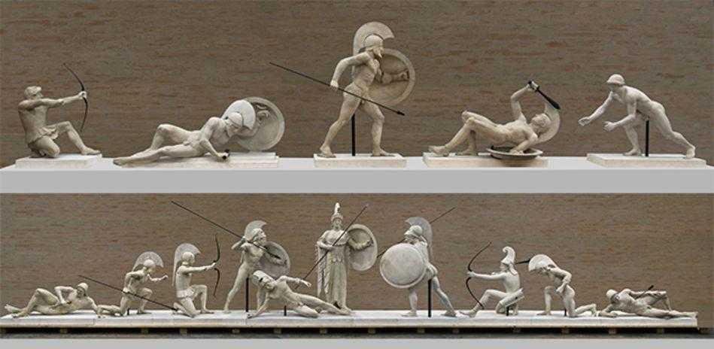
Pediments often contained a heroic narrative.
We know that Picasso had the ancient city of Numantia in mind as he represented the German attack on Guernica. Numantia was a Celtiberian settlement in the Iberian peninsula in the 2nd century BC. It is famous for its role in the Celtiberian Wars against the Roman invaders around 155 BC. After 13 months of siege, the Numantians decided to burn the city before surrendering.
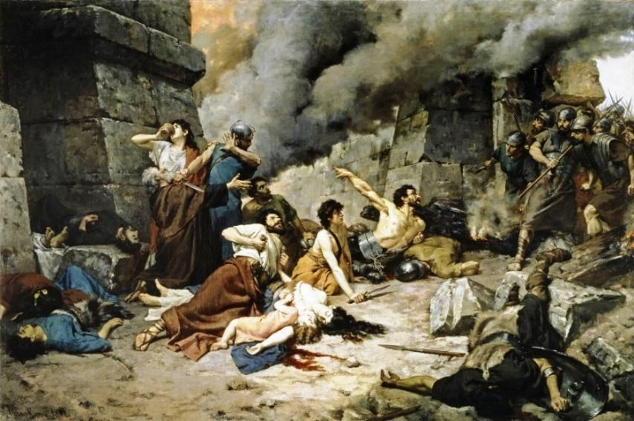

Alejo Vera Estaca. Numantia. 1881

Numantia is famous city for its role in the Celtiberian Wars. In 153 BC Numantia experienced its first serious conflict with Rome. After 20 years of hostilities, in 133 BC the Roman Senate gave Scipio Aemilianus Africanus the task of destroying the city. He laid siege to it, erecting a nine-kilometer fence supported by towers, moats, impaling rods and so on. After thirteen months of siege, the Numantians decided to burn the city before surrendering to the Romans.
In his paintings and prints of the 1930s, Picasso transposed surrealism on to the history of art. The Surrealists sought to release the unconscious, but in high European painting violent erotic fantasy had never been fettered, most graphically in the demonic art of Peter Paul Rubens. The Dutch artist led him to an imaginary space, the world of painted violent fantasy that the older artist had discovered in exotic hunts and that Picasso now found in the bullring. Rubens’ The Consequences of War was a commentary on a European continent ravaged by the Thirty Years’ War.
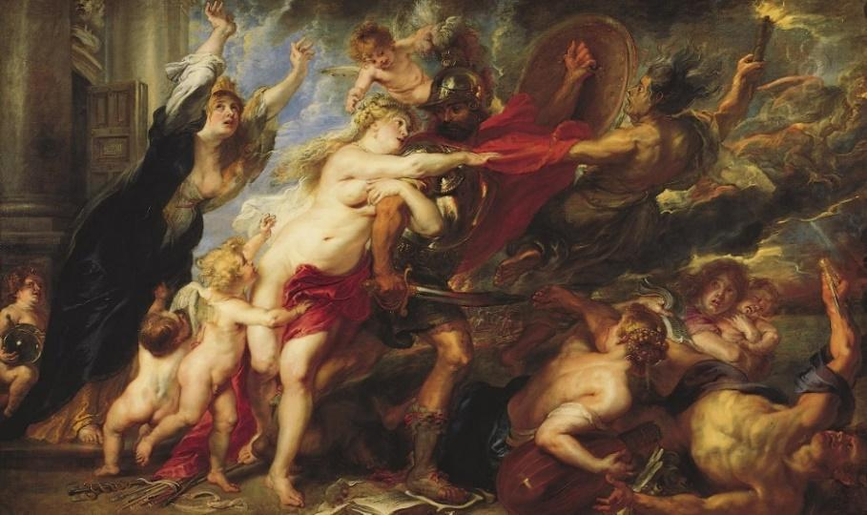
Pieter Rubens. The Consequences of War. 1637-1638

In this painting, the swirl and sweep of his hunting pictures turned to the mad rush of Mars to destroy. A village burns. A woman shields her child. War has been unleashed. There is no doubt that Picasso took this canvas as one of his models when he conceived Guernica in 1937. Rubens’s woman with her child cowering before Mars becomes, in Picasso’s mural, the woman holding a baby whose face is a brief cartoon of death.

7.6. Formal Components of Art.
In this section, students explored the formal art elements form the basis of the language of art; they consist of eight visual parts: line, color, form and shape, value, texture, space, and movement. Line is one dimensional path of a point through space. Generally, verticals, horizontals, and diagonals are directional lines, whereas zigzag and curved lines are movement lines. Shape is a two-dimensional area defined by a clear border or outline and possessing only height and width. Form is a three-dimensional shape or object. Form has height, width, and depth, and may be organic or geometric. Space refers to a feeling of depth or three dimensions. It can also refer to the artist’s use of the area within the picture plane. The area around the primary objects is known as negative space, while the space occupied by them is known as positive space. Texture is a surface quality or appearance. Value is the relationship between tones (ranging from light to dark), and the degree of lightness or darkness of a color. Color is the quality or wavelength of light emitted or reflected from an object.
In Guernica, we observe a predominance of clearly defined geometrical elements. We also know that Picasso intentionally chose to paint the mural in extremely monotone hues consisting only of black white and greys to link its representation with the newspapers where he initially read the reports of the bombing.
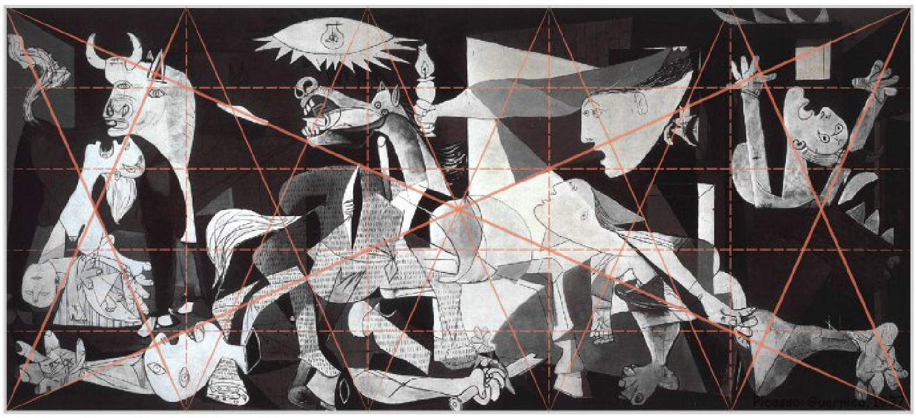

One of the formal elements of art has to do with a repeated pattern or design. A motif may also consist of an element in the iconography of a particular subject or type of subject that is seen in other works, or may form the main subject. In this case the pattern has to do with the referential content of the work. A motif is often a recurring narrative element with symbolic significance. Motifs in a particular composition must be related to the central idea of the work, and they always end up reinforcing the author’s overall message.
Among the motifs we find in Guernica are the already mentioned are the figure with extended arm; the mother and dead child; the woman fleeing, the figure with raised arms.
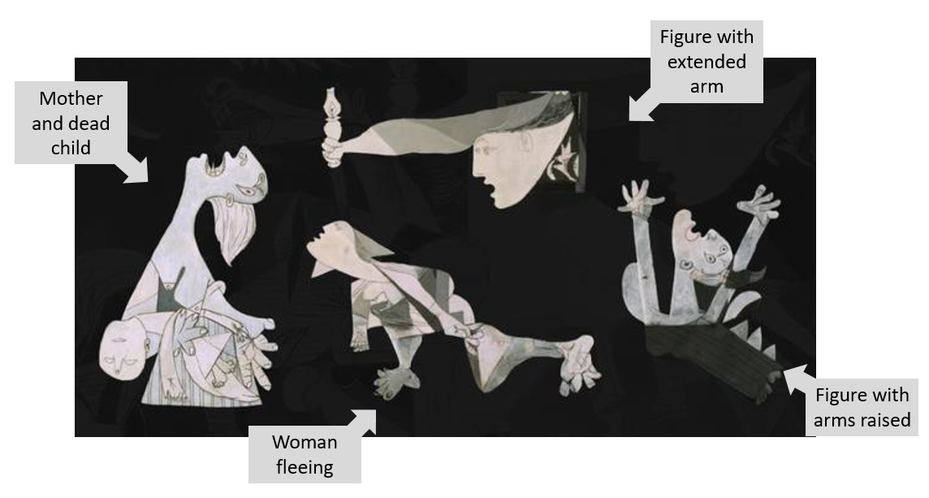

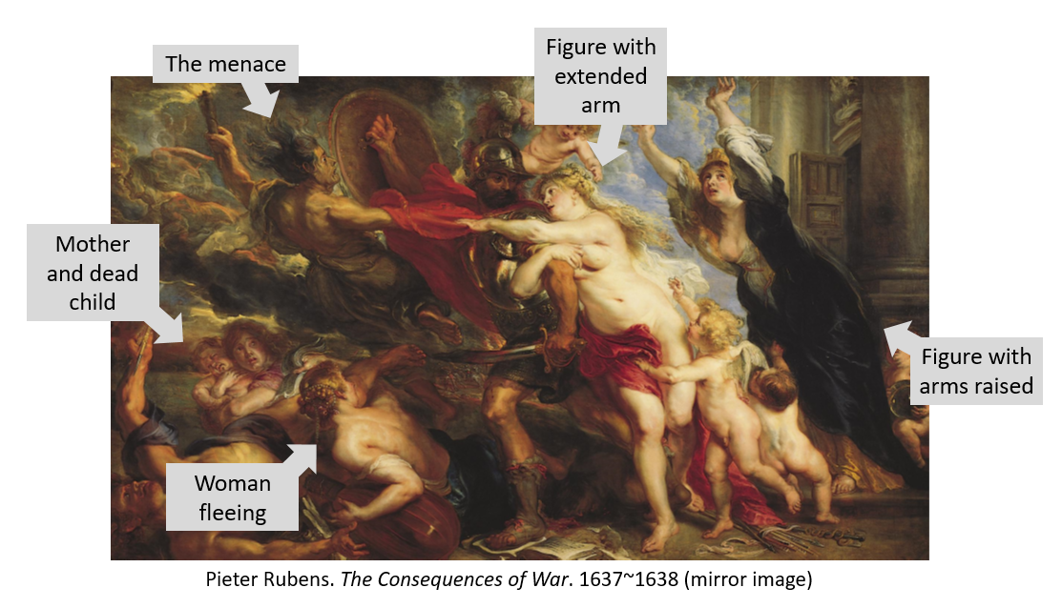

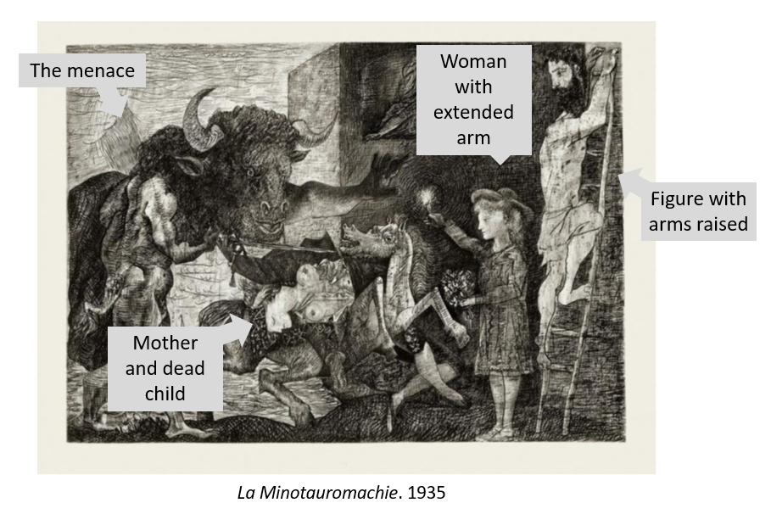
As shown above, we find these same motifs are also found in Peter Paul Rubens’ painting as well as Picasso’s former etching La Minotauromachie. The menace which is introduced in Guernica with the bull on the left, is represented in Rubens and in Picasso’s prior work by the god Mars and the Minotaur, respectively.

8. Faculty-Led Group Discussion.
After student groups had presented their segments covering historical, biographical and cultural facts, as well mythology, art history factors and relevant formal artistic elements, the entire class is led into a group discussion. My primary role in this section was to serve as a facilitator and guide, fostering interaction among my students. The class discussion of the artwork focused on three questions: (1)What features do YOU see in the painting?; (2) What do YOU think Picasso is trying to communicate; and (3) How would YOU communicate these same events?

9. Individual Student Projects.
Students were asked to create a “virtual exhibition” that would best illustrate the artist’s formal and emotional content. Not surprisingly, the so called Blue Period was one of the students’ favorites. This group of works tends to show outcast members of society such as the impoverished class. Other popular works were those belonging to the Iberian Period where Picasso focused on his Spanish roots.
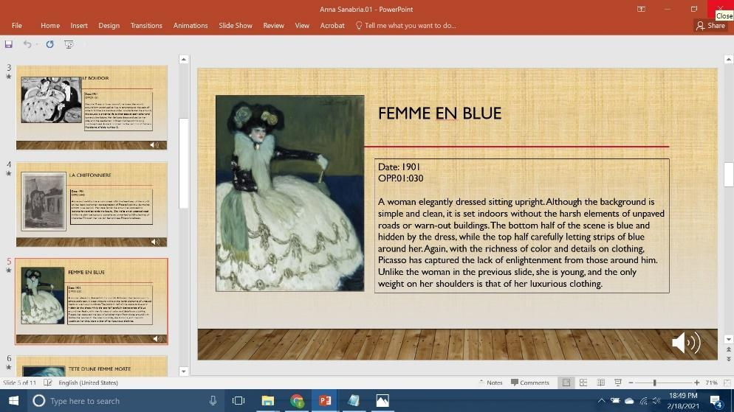
By Student A
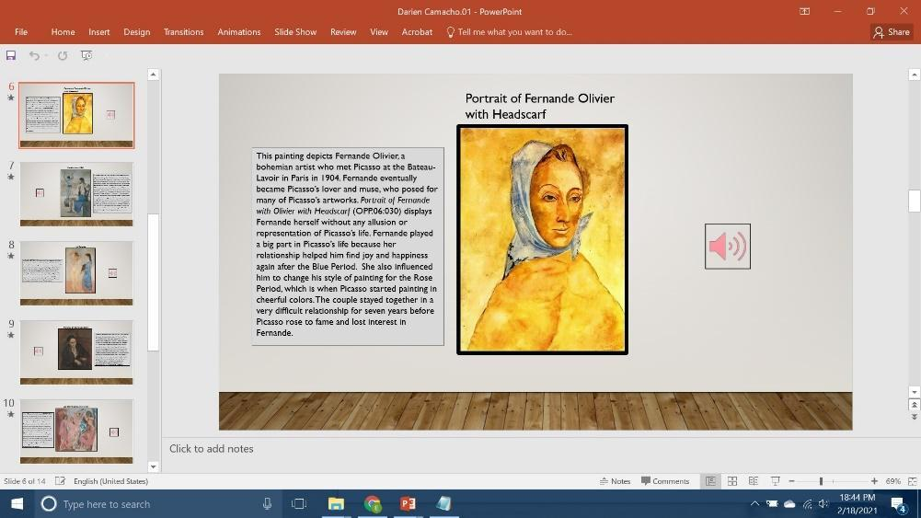
By Student B

They were also asked to post an “alter ego” collage, placing themselves in Picasso’s shoes, trying to understand why he used different themes and modes of expression throughout his life, and thus encouraging SEL learning. The collage had to contain illustrations of relevant works, as well as textual explanations. Most of the students’ collages showed a clear influence of Picasso’s best known contribution to art, namely Cubism, in their formal construction. However, when it came to their chosen themes, I could see a clear correlation between historical paintings like Guernica as students reflected on recent tragic events like Black Lives Matter, the pandemic or the immigration crisis in Latin America.
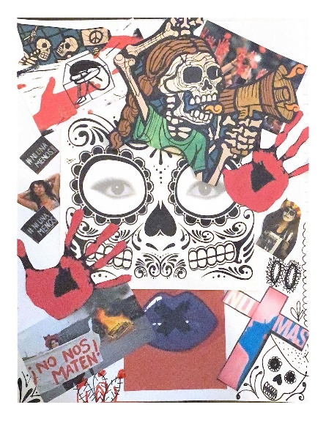
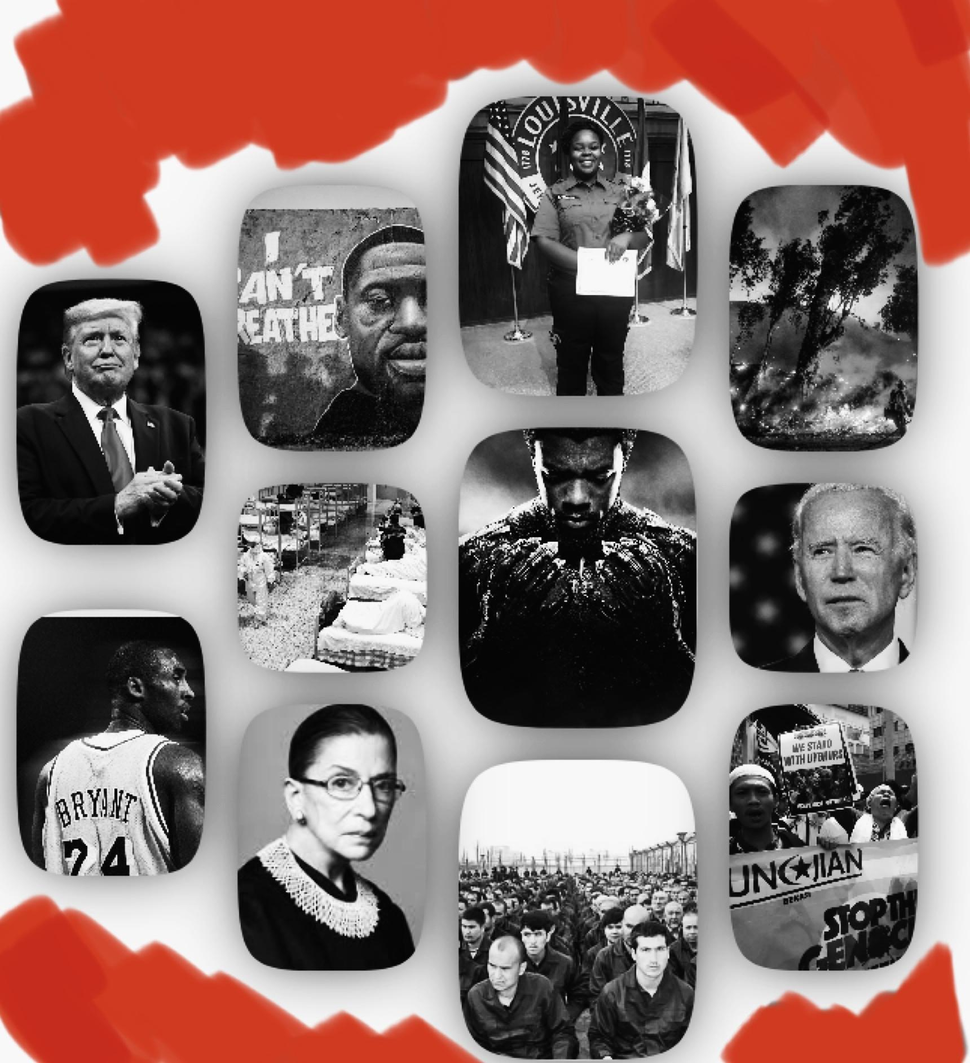

By Student C and Student D
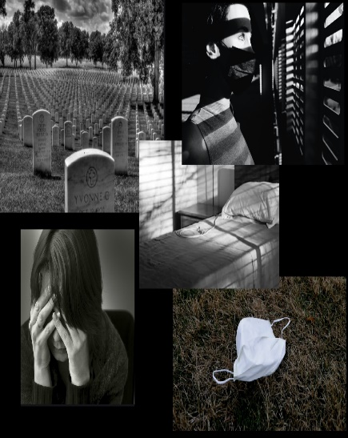

By Student E and Student F
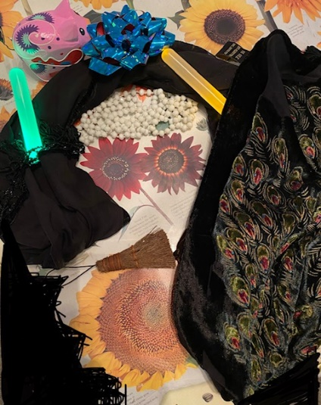
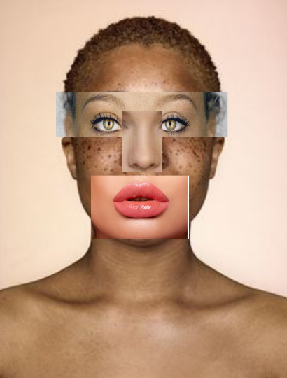

By Student G and Student H
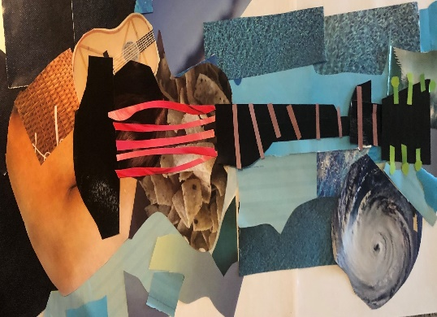
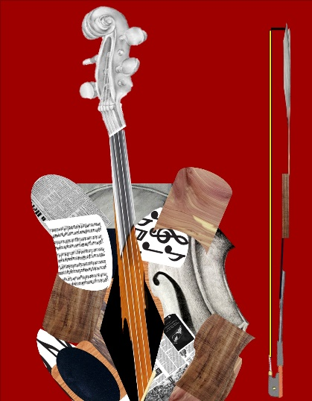

By Student I and Student J

10. Other Active Learning techniques.
Other Active Learning techniques I used in my course included Think-pair-share, where I asked students to take a moment to think about the content of the day’s lesson, and then share their thoughts with one or more of their peers. This was followed again by a general discussion where they presented their conclusions to the entire class. In this final phase, I stepped in as a guide as needed to clarify information.
Another technique that was really productive was Quick Write, in which a prompt was posed for students to respond to in writing. Having previously assigned readings on certain works by a Spanish artist, I would then ask students to take five minutes to write about them. This was an effective way to engage them in thinking about the topic covered in the session, and to provide them with the opportunity to access their prior knowledge on the topic. I would ask several students to read their brief summaries to the rest of the class.
I also used the technique of Sorting Strips, where small bits of information were separated into strips so that students could sort them into various categories, or organize them into a sequence depending on the topic. This became very productive with Picasso given the large amount of works he produced, his longevity and the fact that many of the periods that have been proposed for different spans in his career often overlap. This strategy encouraged a very productive discussion of competing ideas or different approaches to the organization of facts.
Finally, one learning technique that was quite useful for my class was Posters & Gallery Walk where groups of students were given an assignment that they needed to work on together and present their conclusions on a sheet of chart paper. This was different from the “virtual exhibitions” which were based on individual work by each student. Once they had completed their poster, they were asked to display it on the wall, much like at a scientific poster session. One of the members of the group stayed with the poster and helped explain it as the classmates circulate to look at all the posters. This allowed for a more interactive delivery method as compared to simple PowerPoint presentations.
In these and other student tasks, I have seen the clear benefits of Active Learning and SEL. My students showed greater comprehension and memory. The activities improved their critical thinking and also led to more positive attitudes towards learning as a whole. Additionally, I noticed increased enthusiasm in my students for the topics discussed in the course.

11. Active Learning Challenges.
While Active Learning offered exciting opportunities for dynamic and interactive learning, it also presented unique challenges that did not exist in my previous lecture-based classes. I had to supplement written tests with creative individual and group projects since tests do not accurately reflect student active performance and are also hard to administer in an Active Learning classroom. Instead, I started assigning grades for in-class and at-home group work, collectively and individually.
I also noticed that adding Active Learning projects to my class made it harder to go over every point I used to cover in my lectures. So what I did was cover fewer topics in more depth, and then encouraged students to explore other topics as group projects. I also required students to read additional materials relevant to the topic at hand before coming to class, so I could invest the class period in active tasks. I find that the increase in student feedback enabled me to move more quickly through topics that were easily understood, and concentrate instead on more difficult areas.
Another challenge I found involved the classroom arrangement. Active Learning requires one to have various focal points, as a result, some of my students had to turn around to view their classmates, making it harder to take notes or see the projection screen. I helped by moving around and standing in different places throughout the room so that students got equal face time with me.
From time to time I found that certain students were reluctant to fully interact with their classmates. I explained from the beginning that the class required student involvement in the course. To remedy this, I often called on the less active students so that they would join in the discussion. This problem also applied to less productive groups. Some had a hard time remaining on task and working together towards the outcomes I had planned. To solve this problem, I created a mechanism to collectively and individually assess how group members were performing. This created accountability, stressing the importance of cooperative work.

12. Assessment and Dissemination.
With the shift in learning objectives that are more focused on the development of skills and processes, new assessment techniques must be developed to determine the effectiveness of Active Learning techniques for teaching these skills. In order for assessment to be done well, I first considered the learning objectives I was assessing and what benefits would derive from the process. I would then conduct my assessments during, as well as after, the learning process.
In my assessment, I covered all of the cognitive levels (remember, understand, apply, analyze, evaluate, and create) in my learning objectives and outcome methods. The latter involved interactive and directed discussions, presentations, as well as individual and group projects. Through student-peer feedback, I checked for students’ ability to evaluate the progress in all my students. At the end of the course, I evaluated the Active Learning strategies I had implemented by comparing before and after results. My students had not only gained a better understanding of Spanish art and culture, but they were also more aware of the circumstances surrounding that art and culture; they were able to relate emotionally to current events and express their reaction to them visually.
I compared my IDEA course scores for SPAN 465 in Fall 2017 and Fall 2020 in order to confirm students’ opinion on their academic and ethical development after the completion of the course. The course was taught in Fall 2017 using primarily a lecture approach, while the one taught in Fall 2020 implemented Active Learning and SEL.
IDEA EVALUATIONS for SPAN 4365 | F2017 | F2020
Helped students to interpret subject matter from diverse perspectives | 4.50 | 4.77
Encouraged students to reflect on and evaluate what they have learned | 4.67 | 4.69
Demonstrated the importance and significance of the subject matter | 4.33 | 4.77
Stimulated students to intellectual effort beyond that required by most courses | 3.83 | 4.46
Related course material to real life situations | 4.00 | 4.38
Created opportunities for students to apply course content outside the classroom | 4.00 | 4.46
Introduced stimulating ideas about the subject | 4.00 | 4.77
Involved students in hands-on projects such as research, case studies, or real life activities | 4.17 | 4.54
Inspired students to set and achieve goals which really challenged them | 4.00 | 4.46
Asked students to share ideas and experiences with others whose backgrounds and viewpoints differ from their own | 3.83 | 4.54
Asked students to help each other understand ideas or concepts | 3.83 | 4.54
Gave projects, tests, or assignments that required original or creative thinking | 4.17 | 4.85
Learning to apply course material (to improve thinking, problem solving, and decisions) | 3.83 | 4.23
Developing creative capacities | 3.83 | 4.69
Gaining a broader understanding and appreciation of intellectual/cultural activity | 4.50 | 4.92
Developing ethical reasoning and/or ethical decision making | 4.17 | 4.77
Learning to analyze and critically evaluate ideas, arguments, and points of view | 4.33 | 4.62
Learning to apply knowledge and skills to benefit others or serve the public good | 3.83 | 4.00

We notice that there was a substantial increase in the scores for all the categories listed. I want to bring attention, however, to those where the score dramatically improved. Those categories where Active Learning was inferred scored higher: in “Stimulated students to intellectual effort beyond that required by most courses,” it went from 3.83 to 4.46; in “Created opportunities for students to apply course content outside the classroom,” from 4.00 to 4.46; in “Inspired students to set and achieve goals which really challenged them,” from 4.00 to 4.46; and in “Introduced stimulating ideas about the subject,” from 4.00 to 4.77. Those where SEL was at play, involving collaboration, ethics and empathy, also saw a high increase: in “Asked students to share ideas and experiences with others whose backgrounds and viewpoints differ from their own,” from 3.83 to 4.54; in “Asked students to help each other understand ideas or concepts,” from 3.83 to 4.54. Finally, creativity and problem solving saw a high increase: in “Gave projects, tests, or assignments that required original or creative thinking,” it went from 4.17 to 4.85; in “Learning to apply course material (to improve thinking, problem solving, and decisions),” from 3.83 to 4.23; and in “Developing creative capacities,” from 3.83 to 4.69.
I also elicited feedback from other faculty members on whether or not they felt that the activities I had implemented in my course were ideal to achieve Active Learning and SEL. They all agreed that, based on their own experience, the activities I implemented were clearly conducive to better outcomes in these areas, and they said they would replicate many of them in their own courses.
As mentioned earlier, I have already disseminated my findings by participating in conferences such as the Digital Education Summit, the SHSU Teaching & Learning Conference and the Universality of Global Education Conference, and in presentations like the one I gave in my department at the Language Learning and Teaching Workshops Series. I would also be hosting an Active Learning Workshop in my department using some of the ideas developed for this course.

13. References
Adams, D. & Hamm, M. (1994). New Designs for Teaching and Learning. Jossey-Bass Publishers: San Francisco.
Anonymous. “Hierarchy of the Genres: How Paintings Were Ranked by the Academies of Fine Art.” Encyclopedia of Art History. http://www.visual-arts-cork.com.
Bean, J. C. (1996). Engaging ideas: The professor’s guide to integrating writing, critical thinking, and active learning in the classroom. San Francisco: Jossey-Bass.
Bell, B. S. and Kozlowski, S. W. (2008). “Active learning: effects of core training design elements on self-regulatory processes, learning, and adaptability.” Journal of Applied Psychology 93(2): 296-316.
Belton, R. J. (1996). “The Elements of Art”. Art History: A Preliminary Handbook. University of British Columbia.
Davis, W. (2018). A General Theory of Visual Culture. Princeton, NJ: Princeton University Press.
Elmi, C. (2020). “Integrating Social Emotional Learning Strategies in Higher Education.” European Journal of Investigation in Health, Psychology and Education. 10, 848–858
Felder, R. and Brent, R. (2009). “Active learning: an introduction.” ASQ Higher Education Brief 2(4).
Frank, P. (2002). Einstein: His Life And Times. Lebanon, IN: Da Capo Press
Freeman, S., et al. (2007). “Prescribed Active Learning Increases Performance in Introductory Biology.” CBE-Life Sciences Education 6(2): 132-139.
Gallagher, K. M. & Stocker, S. L. (2018). A Guide to Incorporating Social-Emotional Learning in the College Classroom: Busting Anxiety, Boosting Ability. Washington, DC: American Psychological Association.
Jenks, C. (1995). Visual Culture. New York: Routledge.
Linden, R., et al. (2016). Innovating Education and Educating for Innovation: The Power of Digital Technologies and Skills. Paris: OECD Publishing.
Mitchell, W. J. T. (2015). Image Science: Iconology, Visual Culture and Media Aesthetic. Chicago: University of Chicago Press.
Nakamura, L., ed. (2008). Digitizing Race: Visual Cultures of the Internet. Minneapolis: University of Minnesota Press.
Raver, C.C., & Knitzer, J. (2002). Ready to enter: What research tells policymakers about strategies to promote social and emotional school readiness among three- and four-year-old children. Chicago: Harris School of Public Policy Studies, University of Chicago.
Waterton, E. & Watson, S. eds. (2016). Culture, Heritage and Representation: Perspectives on Visuality and the Past. Farnham: Ashgate.

