Global Migrant Crisis: Teaching and Learning on Zoom While Facilitating Intergroup Dialogue

Theresa Carol Bodon, Ed.D
Department of Mass Communication, Sam Houston State University

Author Note

Theresa Carol Bodon, The Department of Mass Communication, Sam Houston State University.
The Honors College, Sam Houston State University.
There is no known conflict of interest disclose.
Correspondence concerning this article should be addressed to Theresa Carol Bodon,1804 Avenue J. Dan Rather Communication Building Box 2207 Huntsville, Texas 77341-2207
E-mail: tcb019@shsu.edu

Abstract

This paper is a reflection of teaching and learning experiences about a dialogue seminar entitled the Global Migrant Crisis taught during the Covid-19 pandemic. Insights into the outcomes of student learning development of critical pedagogy are conveyed in the course design and materials. Through the professor’s observations and experiences, perceptions into developing course designs within a virtual learning environment using the medium of the Zoom platform shed light on the andragogical needs of undergraduate students. Also, utilizing Paulo Freire’s philosophical stance, the study of the class design provides a contextual approach to educational practices in relation to intergroup dialogue within seminar modes of teaching and learning in virtual learning environments.
Keywords: intergroup dialogue, education, pedagogy, Zoom platform, online learning, migrants, refugees, mass communication

Global Migrant Crisis: Teaching and Learning on Zoom While Facilitating Intergroup Dialogue
Introduction
In 2015, with onset of wars, revolutions, oppressive religious and political regimes, erratic climate change, and economic instabilities, more than 60 million people worldwide were forced to leave their homelands in hope of finding better lives. Countless migrants had perished during their journeys across vast deserts and treacherous seas. The people who succeeded in their escape from the socio-political and climatic disasters of their homelands found themselves trapped in camps worldwide (e.g., Bodon, 2017). In 2016, over 10,000 refugees and migrants lived in a camp known as the Jungle in a Northern town in Calais, France. People of many origins such as the Middle East and Africa were living in this inhuman encampment while enduring the traumas of war torn and uninhabitable environmental conditions. Their only hope was to leave their homelands for the United Kingdom where they could reunite with family members and create a whole new life. Accordingly, with the situation of migrants living in camps in Calais, I decided to conduct my dissertation research based on the global migration crisis within a critical hermeneutic phenomenological framework. The study included a documentary that aimed to represent the perspectives of the refugees and migrants living in an unregulated refugee camp known as the Calais Jungle.
Upon the completion of my doctoral research, I created a course designed to engage undergraduate students in intergroup dialogues centered on the topics of the global migrant crisis. The course was taught to undergraduate honors students based on a seminar format. The honors course was designed in three units: Unit one began with personal reflections about the students’ immigration and cultural backgrounds. Once the students expressed their perceptions and experiences of immigration, they engaged in readings related to the global migrant crisis such as (a) nationalistic governance of migration and refugees, (b) theoretical frameworks of migration and immigration, (c) historical aspects of immigration, (d) the stories and memoires written by migrants and refugees, (d) dialogues with guest speakers who lived and worked in the Calais Jungle, and (e) a migrant solidarity group research project. Additionally, Unit two transitioned students’ dialogues about migrant issues through a visual analysis of (a) fictional films that represented migrant topics (b) refugees’ stories through the expression of their art and fictional books, and (c) student dialogue through the university common reader deliberative dialogue events. Additionally, I intended to engage students in assisting refugees in the Houston area. For example, originally with Unit three, I planned to have students observe public court hearings of refugees and engage them in creating cultural and educational events with refugees in the Houston area. However, this unit was improvised due to the Covid-19 pandemic. To accommodate for the intended active engagement activities, I extended the migrant solidarity project as an online ethnographic research experience and have students to participate in the deliberative dialogue events.
In 2020, the situation of face-to-face seminar courses became restricted to blended, hybrid, or fully remote due to the Covid-19 situation. Fortunately, I could conduct the course through the medium of the Zoom platform. Indeed, many health barriers were imposed during the pandemic, yet with the medium of virtual environments, as teachers and students we were able to improvise and engage in intellectually stimulating intergroup dialogues. In this sense, could the Zoom platform be an effective medium for teaching and learning in relation to the idea of universality of global education? Is the platform a sustainable tool for education which is inclusive to diversity and vulnerable populations? For this paper, I incorporated my experiences teaching an honors dialogue course on the global migrant crisis and the experiences teaching on the Zoom platform. The philosophical design of the course was centered on Paulo Freire’s teaching critical conscience, which involved the pedagogical designs that facilitated intergroup dialogues and students’ advancement of their understanding of existential and global issues as well as the advancement of their language and expression of such issues. Furthermore, this paper illustrates the professor’s observations of learning processes using the Zoom platform and provides insights into the medium of Zoom as an effective medium for learning and teaching.
Review of Literature
Although studies were conducted related to online learning environments, there was a lack of research in relation transitions from face-to-face to Virtual learning environments using the Zoom platform. According to Bishop-Monroe (2020), more studies ought to be conducted for teachers to consider the challenges and practical solutions to developing an intellectually and emotionally stimulating remote learning environment. Indeed, such studies could help teachers who were in transition from face-to-face to better prepare and improvise remote learning. Accordingly, with a lack of published information in transition from face-to-face to virtual teaching, researchers expressed the challenges they faced while teaching on the Zoom platform. Nguyen (2021) posited that the behavioral challenges relative to students’ reluctance to turn on their cameras during class meetings was due to their concerns about privacy issues. Nguyen stated that he agreed with the students’ argument and accepted their requests to deactivate their cameras, thus every student decided to do the same. In this sense, Nguyen stressed that teachers needed more support to improve virtual classroom teaching methods. Indeed, such behavioral issues could be addressed to students to facilitate a secure and intellectually stimulating environment. However, there was a lack of information and support for virtual learning on platforms such as Zoom.
In retrospect, qualitative studies in the field of medical education revealed success and innovations that remote learning sessions provided. According to Ohnigan, Richards, Monette, and Roberts (2021), many medical educators did not have the experience planning or leading Zoom sessions for their classes. Despite the prevalence of Zoom learning there was little published on the best practices. Additionally, researchers Anand, and Man, Gajanan, and Manson (2020), published their experiences teaching medical students spirometry on Zoom. The researchers illustrated how the students could analyze graphs captured in the teacher’s laptop by remotely controlling the teacher’s laptop. Accordingly, the researchers suggested that there was a lack of studies related to the advantages of using hands on methods that enhanced learning on the Zoom platform.
Universality of Education and Virtual Learning
Furthermore, a primary source publication supported the idea that Covid-19 created a pedagogical shift in how South Africans teach and learn. This shift in pedagogy created many challenges to South African schools and students. However, the effects in relation to universality of education were expressed as a platform that could close the gap between the haves and have nots. As noted by Gopal (2020), “some students may experience some discontent and trepidation online, teaching online will give more South Africans higher education opportunities. All made by Covid-19” (para 15). Additionally, a survey study conducted by researchers from the United Emirates illustrated the challenges that students and teachers faced while transitioning to remote using various digital platforms. The study revealed that remote learning during the Covid-19 pandemic was a good alternative solution to face-to-face (Al-Karaki, Ababneh, N. Hamid, Y., and Gawanmeh, A., 2021). The researchers also found that the main component that hindered the student participation was proper infrastructure at home and especially with hands on courses. Indeed, there was a lack of studies in cognitive learning theory and how to incorporate pedagogy into a successful virtual learning course (e.g., Ohnigan, S. and Richards, J.B. et. al., 2020). Also, the literature showed a lack in the benefits of online education as a medium of sustainability and democratization of education, thus filling the gap between the haves and have nots. In this sense, it is essential to develop both qualitative and quantitative studies that will help educators to develop remote learning that can mirror face-to-face learning. Also, further studies that demonstrate the effectiveness of online education and sustainability of education in developing countries and vulnerable populations was imperative as of writing this literature of review.
Furthermore, this paper illustrated the professor’s perspectives about teaching on Zoom during the Covid-19 pandemic as well as provided insights into issues of sustainability and inclusion of education during pandemics. Also, perceptions from educators about their experiences teaching on Zoom could expand and enrich student experiences by revealing problems and possible solutions to virtual platforms.
Proxemics and Pedagogy
Anthropologist Edward T. Hall (1990/1959) defined proxemics in the context of culture and communication, “Spatial changes give a tone to a communication, accent it, and at times override the spoken word. The distance between people as they interact with each other is part parcel of the communication process” (p. 175). Using Hall’s theory of proxemics educators could expand on studies related to the effectiveness of utilizing Zoom platforms in online learning environments. Hall (1990/1959) identified proximal space in relation to the cultural aspects of Americans and shifts in voice associated with specific ranges od distance as follows (a) very close space, 3-6 in. soft whisper, (b) close space, 8-12 in. audible whisper, (c) near distance, 12-20 in. indoors and soft voice, outdoors full voice, (d) neutral 4-5 ft. soft voice, personal subject matter, and full voice, information of non-personal matter, (e) public distance 5-8 ft., full voice with slightly over-loudness (f) across the room 8-20ft., loud voice, talking to a group and (g) stretching the limits of distance 20-24 ft. Accordingly, voice volume ranges between distances is a cultural structure, that the behavioral and perceptions of voice ranges in different spaces differ from culture to culture. Likewise, interpersonal gestures also differ according to distance and environment. Bodon (1998) stated “We all express ourselves differently according to our relationships that we have when communicating. As the situation and the relationships, we have with others vary, so does our actual physical distance between ourselves and other people” (p. 37). Bodon (1998) explained proxemics in terms of cinematic language and the way actors or actresses transformed their behavior according to the cinematic proximity. For example, there are four proximal cinematic focal points which the actor or actress must adjust to (a) close-up shot, intimate, (b) medium close-up shot, casual, (c) medium shot, social, and (d) long shot, public. An actor or actress must adjust their vocal tone and expansive body gestures as the shots move from intimate to public (Bodon, 1998). Accordingly, a close-up shot would require a lower or softer voice and nonverbal language would mostly consist of facial movements since the proximity is intimate the casual language is emulated in proximity between people. On the other hand, a long shot emulates public distance which in terms of communications would require social or public language, louder voice, and body gestures. Similarly, cinematic proximity and language mirrors the effects of interpersonal communication in both virtual and embodied classroom environments. Regarding virtual classrooms in relation to proxemics, students and teachers would experience casual proxemic language, which reflects physical classrooms as well. Casual proxemics are not commonly prevalent in all class environments. For instance, because proxemics depends on the size and design of a classroom, which will determine the casual, social, or public communication of the class environment. In this sense, for example, most traditional classrooms are designed to emulate a social or public communication environment. In relation to the Zoom platform as a medium of communication, it reflects a casual and seminar design.
Additionally, a recent qualitative survey showed proxemics of virtual learning environments to benefit people with learning disorders especially individuals with (a) anxiety disorders, (b) autistic spectrum, and (c) various other mental health disorders. Davidson and Parr (2010) posited, “Individuals with various and often recoverable mental health problems can benefit from practicing social relations and re-establishing boundaries online” (p. 78). In this sense, the researchers suggested that further studies needed to be conducted about the benefits of virtual classrooms in relation to vulnerable populations, including individuals with physical and mental disorders, as well as individuals without disorders. These studies indicated the need for further research in the area online classrooms using platforms such as Zoom. Indeed, with the recent Covid-19 pandemic, which threatened the health of society, educators must understand the challenges of virtual learning and create solutions toward developing a creative and intellectually stimulating learning environment while sustaining learning for all students.

Sample Group
Although this was not a constructed behavioral study, rather a reflection of the educational experiences, the participants included thirteen undergraduate honors students. The students were from different nationalities and ethnic backgrounds such as Nigeria, India, South and Central America, and North America.
Philosophical Framework
Utilizing Paulo Freire’s model of critical conscious, this undergraduate class was designed to emulate Freire’s philosophical standpoint by creating an educational environment that supported relationships between the subject of global migration and sustainability of trust between the students, which in turn transformed students’ mindsets about the topics from “naïve” or apathetic conscience toward critical conscience, while developing dialogue between students and people outside the university setting. Freire (2013/1974) wrote, “critical consciousness is integrated with reality; naïve consciousness is superimposed itself on reality; and fanatical consciousness whose pathological naivety leads to the irrational, adapts to reality” (p.14). In other words, the pedagogy of critical conscience is about teaching students to advance language while awakening their conscience about situations and concepts in a way that they can relate to. Freire (2013/1974) defined critical consciences as a representation of “things and facts as they exist empirically, in their causal circumstances…naïve conscience considers itself superior to the facts, in control of the facts and free to understand it as it pleases” (p. 41).
Accordingly, in relation to the honors class, students’ dialogues reflected the pedagogical processes of advancing to critical conscious as Freire expressed in his philosophy and application of theory. For example, during the first few weeks of the semester, students’ perspectives expressed their viewpoints based on their feelings or preconceptions about migrant issues, which revealed naïve conscience. For example, after reading extensively and engaging in discussion with guest speakers who lived in refugee camps, a student commented, “she imagined that her day-to-day reality was “like crap,” yet after learning about the experiences of refugees, her perspectives transformed to critical conscience and she realized that the challenges and barriers that refugees face and endure were extremely difficult, and an experience that she found difficult to fathom. With this, the student’s knowledge of the facts about refugee processes became prominent in the class dialogue. Additionally, similar to Freire’s teaching, dialogues in the class were open-ended to allow students to develop relationships within the group and to advance dialogue. Moreover, students expressed a lack of understanding the processes of refugees and migrants, which is essential in understanding the reality of the global migrant crisis. However, as they progressed with the (a) readings, (b) research, (c) engaged with guest speakers (d) interviewed members of humanitarian organizations, and (e) expressed themselves through intergroup dialogues, they demonstrated transformity or transformation from naïve to a critical understanding the global migrant crisis. This developmental process was facilitated by the professor through the design of the course materials and experiences provided to the students. The expected outcome resulted in student lead critical dialogues with continuity of the course topics, as well as extended to the dissemination of their knowledge through the university wide dialogues based on migrant experiences.
Furthermore, drawing from Hall and the theory of proxemics, the issues related to teaching on Zoom platforms was an essential aspect of teaching the honors course. In this sense, by understanding the effects of proximal communications assists both students and teachers to develop a positive learning experience using the Zoom platform. For example, at the beginning of the honors course a few students did not activate their cameras for various reasons. However, the issue was resolved by explaining to the students that face-to-face classes, whether virtual or physically in person, constitutes a casual seminar mode of learning and teaching. Dialogues can progress and be facilitated through a casual virtual environment similar to meeting in a classroom sitting around an oblong table. With this, it is essential to conduct studies that provide insights to educators about virtual classrooms to develop intellectually and creative online environments.
Course Methods and Materials
The course Global Migrant Crisis was designed to engage students in dialogues, while advancing their perspectives about migrant and refugee topics. As a learning enrichment, the aim of the course was to develop meaningful relationships wherein students gained compassion toward refugee and migrant populations through the advancement of dialogues not only with fellow classmates, yet with the global community of migrants and refugees. The design of the course and materials were curated to engage students in textual, visual, aural, inter-personal communications in the traditional classroom setting and outside the formal classroom setting, as well as community engagement related to refugee issues. The course goals were developed for students to transform their perspectives and advance critical thinking about the processes of refugees and migrants through socio-political, socio-cultural, and socio-historical frameworks.
The goals of intergroup dialogue were “aimed at building affective self-other relationships through personal storytelling and sharing, empathy, listening and interpersonal inquiry” (Maxwell, Nagda, & Thompson, 2011, p. 5). In this sense, the first discussions of the course were based on personal reflections about migrants and presentations of one’s own cultural background as it relates to immigration. Additionally, in Unit one of the course, selected texts were encouraged, and they were relevant to the political and global governance of migration. In this sense, students advanced their understanding of the existential issues of migration. Such texts included: Rescue: (a) Refugees and the Political Crisis of Our Time, Refugees, Migration and Global Governance: (b) Negotiating the Global Compact, (c) Undocumented: How Immigration Became Illegal, and (d) additional relevant journal articles. With the readings students were expected to compile questions about the topics within the texts and prepare discussions related to their inquiries. The selected texts provided a knowledge base of historical and political frameworks to advance their dialogues and answer their questions. The method of developing dialogue began with questions about the readings and anonymous peer journal entries about the outcomes of weekly discussions. With the readings and inquiries students were then divided into small groups wherein they would discuss their ideas and questions, as well as narrow their questions to develop dialogues with the class as a whole. For example, using the Zoom platform the professor acted as the facilitator and created breakout rooms of small groups to discuss the readings, and after about twenty minutes of small group discussions the students were expected to develop dialogues with the entire class. As a professor, I found this platform effective because it allowed students to privately discuss their views, which helped them to create open dialogues. Also, the platform allowed screen sharing which helped the class to visualize the topics. Furthermore, the anonymous peer journals related to the weekly discussions also helped the professor guide the dialogue and ease any conflicting discussions that may prevent classmates from responding and engaging in class activities.
Furthermore, the content of the course shifted to non-fictional memoires and documentaries about refugee processes. Texts included: Memoires: (a) No Friend But The Mountains, (b) Voices from the ‘Jungle’: Stories from the Calais Refugee Camp, and (c) a choice of their own non-fictional migrant stories, namely American Like Me: Reflections on Life Between Cultures, the common reader. The selected documentaries included (a) When Paul Came Over the Sea, and (b) my research documentary entitled 5096: Our Camp of Shame. With the non-fictional stories expressed by refugees, I found that the students advanced their critical thinking skills because they began to connect to the existential issues and historical aspects that effect migrants and refugees. At this point, I felt that dialogue was established and open, and the next step was to engage them as much as possible with an embodied experience such as guest speakers who lived and worked in the refugee camp. Accordingly, we knew that the class was halfway through the semester and the climax of the content was beginning. So, with two guest speakers, Brother Maertens Johannes, a monk from Secours Catholique who aided refugees in the Calais Jungle and Babak Inanloo, an Iranian refugee who lived in the Jungle; they joined our class to talk about the current refugee crisis in France and Britain. Indeed, this discussion was the climax of the entire course as students were shocked about the socio-political climate and the inhuman living conditions of refugees in Europe. The dialogues and critical foundations were established, and it was evident in their discussions. At this point, the course moved forward with Unit two on topics related to visual discourses of refugees through their art and media bias depicted in fictional films and fictional stories about migrants. Additionally, to finalize the formative evaluation of dialogues, the students completed a semester long research study on migrant solidarity groups. This study engaged them in online ethnographic experiences by developing a relationship with volunteers in humanitarian organizations, both unofficial and official. This project was experimental, yet the outcome was nearly exemplary because the students engaged in interviews with volunteers from humanitarian organizations. The samples of some outcomes of the course are illustrated in the discussion section.
Discussion
The honors dialogue course entitled Global Migrant Crisis was conducted as a seminar course via virtual Zoom platform reflected the concept of global universality of education in the sense that the medium of Zoom in relation to teaching dialogue courses was an effective method to use in educational settings. Creating an effect of universality within the class setting were evident in that the medium of Zoom provided accessibility to guest speakers from distant and vulnerable populations to share their experiences with university students, which would not have been possible in a face-to-face class. Accordingly, students also felt comfortable to share their views and perspectives with the guest speakers. Also, sustainability of education during a pandemic showed successful with student outcomes and inclusion was accomplished with the availability of platforms such as Zoom. Additionally, the medium’s tools provided methods to engage in virtual break-out rooms for private group discussions, screen sharing, verbal, and written discussions for participants to express aural, visual, verbal, and written ideas.
Furthermore, there were three points of outcomes in relation to the course to discuss (a) reading, writing, and dialogue integration, (b) virtual learning environment inclusion and the impact of Zoom as a medium, and (c) ethnographic online migrant solidarity project. As outlined in the aforementioned methods of the course, students engaged in dialogue about migrant and refugee issues through curated readings, writings, and virtual in-class discussions. Freire’s (2016/1974) methods of developing critical transivity through methodological teaching illustrated the pedagogical processes of the advancement of language through the transformation of students’ perceptions of the world. Critical transivity is acquired through a process of learning self-actualization and critical conscious. This process occurred in stages of teaching and learning experiences as follows: (a) relationship and trust, (b) learning through deconstruction of concepts, (c) shared expressions and reflectivity, (d) student trusting oneself to challenges in the world, (e) achievement through peer recognition.
Reading, Writing, and Dialogue Integration
The first stage that most undergraduate students experience in all classes, is the anxiety of gaining recognition and acceptance from the professor for their academic work. Many students express this anxiety in different forms during the first few weeks of the semester. In the case of this honors dialogue course, students expressed concerns about the workload of readings and asked the professor to subtract some of the readings. In this sense, I had to be lenient on one hand, yet remain consistent with the course content design and the goals to encourage pedagogical transivity. To build a trust, I gave students a choice regarding additional journal readings, but I did not give up the readings from the books as they were essential for building knowledge of the subject and strengthen productive dialogues. Indeed, the course included diverse learners from different reading backgrounds, yet from my experiences in teaching, the more extensive the readings, the more elaborative and focused class discussions will be. This is due in part, as Freire (1974-2016) expressed, the processes of transivity in pedagogy shifts away from naïve conscience toward critical conscience, which relies on the advancement of language and broad foundations of knowledge. The outcomes of effective dialogues through the integration of reading and writing started to show by mid-semester when socio-political and historical frameworks, as well as the stories about refugees advanced and established a more holistic understanding of the subject. From this point, with the integration of guest speakers as a way to engage embodied experiences through inter-personal dialogues revealed the climax of the students’ development in dialogue. Students’ reflections and questions expressed transformity in their perceptions of migrant and refugee experiences. At this point naïve and apathetic discussions transformed to critical discourse. For example, one student asked a guest speaker about his use of a word or expression such as “cultural versus ethnic groups” wherein the guest speaker responded that he did not want to use the terms in the context of the people living in the Calais Jungle. The student asked him to elaborate on his statement which in turn transformed the discussion toward issues of critical race theory, as example. Also, this demonstrated the process of deconstruction of concepts learned through the medium of class readings and discussions. Additionally, psychological indications of self-realization were observable, self-realization that one’s expressions manifested toward knowledge which in turn developed a critical mindset, a realization that one could achieve recognition in the world through intergroup dialogue. Indeed, expressions of one’s ideas and sharing of thoughts and inquiries was found to be essential in pedagogical and andragogical processes. Additionally, the final stages of peer recognition were revealed both through guest speaker dialogues with students and written peer review journals. The anonymous journal entries helped the facilitator to understand the dynamics of the group, and to structure the students’ awareness about group dynamics which in turn assisted the facilitator to guide an effective and inclusive intergroup dialogue.
Ethnographic Online Projects and the Migrant Solidarity Project
The migrant solidarity project that I curated for the class was inspired by ethnographic elements. As noted by Spradley (1979), “rather than studying people, ethnography means learning from people” (p. 3). One of the goals of the course were for students to learn from migrants and refugees, and to engage in interpersonal correspondence through informal or formal interviews with volunteers working for humanitarian organizations. In this sense, I introduced elements of ethnographic approaches, such as (a) building relations with participants via online (b) conducting interviews, and (c) journaling thoughts, events, correspondences, and general information. For example, building relationships with the people is an essential aspect in understanding a group of people or culture. The participants must trust the researcher in order to develop a dialogue. Additionally, journaling is an ethnographic method used to record the ethnographer’s thoughts, the participants’ actions and words, and contextual aspects of the daily life of the people. Furthermore, students experienced interviewing techniques that either created a successful relationship with the participants or in some situations unsuccessful. At any level, the experience of developing relations to create personal interactions and dialogue was one challenge that students in this course were engaged with. The migrant solidarity project was designed in three phases as follows:
Phase 1 the students researched select migrant solidarity groups and chose one to conduct a semi-online ethnographic study.
Phase 2 of the project students journaled the daily posts and information provided by the humanitarian organization and they developed relations with volunteers who work with refugees.
Phase 3 the students attempted to have an interview with volunteers of the organization and journaled all interactions with them via online, open-ended social media platforms, and/or cell-phone communications.
The outcome of this project was interesting because students learned from unofficial and official organizations about daily lives of refugees and volunteers, as well as current migrant issues that humanitarian organizations address. Some of the issues they encountered were determining whether certain organizations were legitimate or not, this engaged them in media literacy techniques as well. Some of the organizations studied mostly through online and cell-phone communications were (a) No Kids in Cages, (b) The Calais Kitchen, (c) Doctors Without Borders, (d) Refugee Rights Europe, and (e) The Info. Bus. Indeed, these organization were legitimate organizations both benevolent and official with exception to one, “No Kids in Cages” wherein the students found some information on the site questionable as well as no responses from volunteers. The following will discuss in more depth the experiences and outcomes of two class groups, wherein “No Kids in Cages,” “Refugee Rights Europe,” and “The Calais Kitchen” revealed samples of student outcomes.
Firstly, I will discuss the student learning outcomes of the migrant solidarity group “The Calais Kitchen.” The following samples illustrated the interactions that students engaged in during their correspondences with volunteers of this unofficial humanitarian organization. The Calais Kitchen consists of volunteers who cook meals daily for refugees and migrants on the Euro-tunnel border in Calais, France. Hundreds and thousands of migrants are forced to live in the outskirts of town in the industrial area where they live in tents without clean water or food. Note that the demographics change through time. These students were able to develop relations with volunteers to gain more information about the situation of the migrant crisis in Calais. During a phone interview with the lead volunteer of the Calais Kitchen, the students expressed that they felt as though they were in Calais experiencing the daily life of working with volunteers. For example, during one phone interview the driver of the kitchen truck was engaged in escaping authorities and expressed that volunteers were often forced to stop feeding the migrants. The following samples represented a snapshot of the students’ presentation and illustrated the interaction they gained from the project.

Sample 1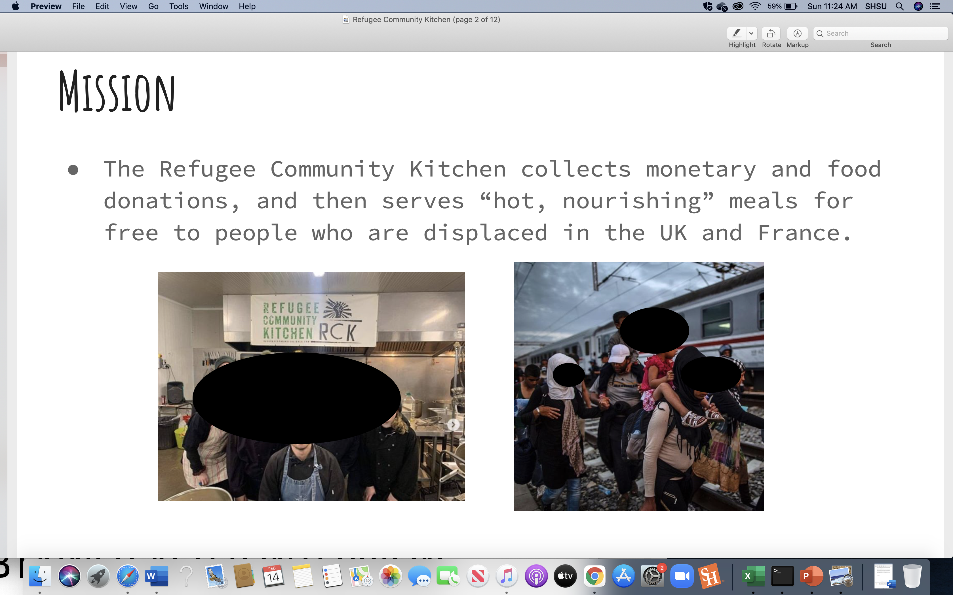Note. A sample of the Calais Kitchen student presentation for the Migrant Solidarity Project. Students engaged in research about humanitarian organizations and the daily lives as a volunteer and migrant issues.

Sample 2
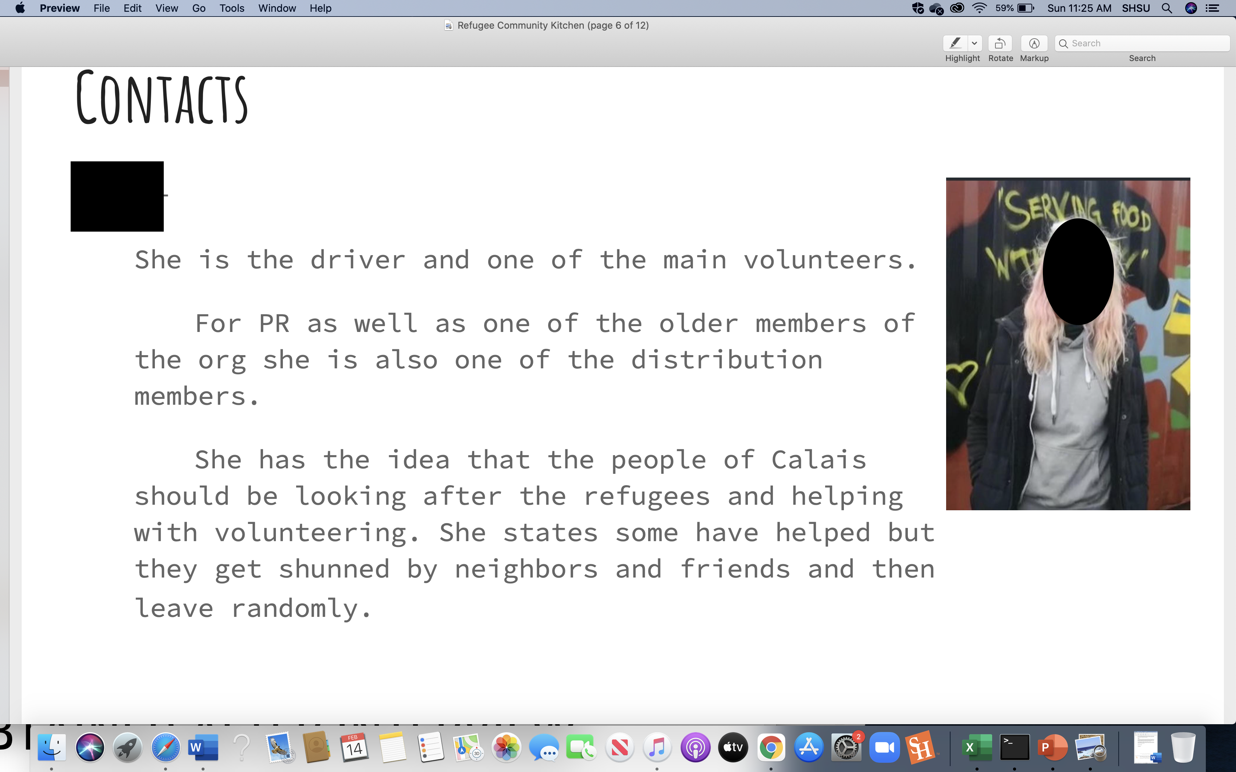

Note. Volunteer worker who was contacted and interviewed by students. Janie worked as a trucker driver and served meals to migrants in Calais.

Sample 3
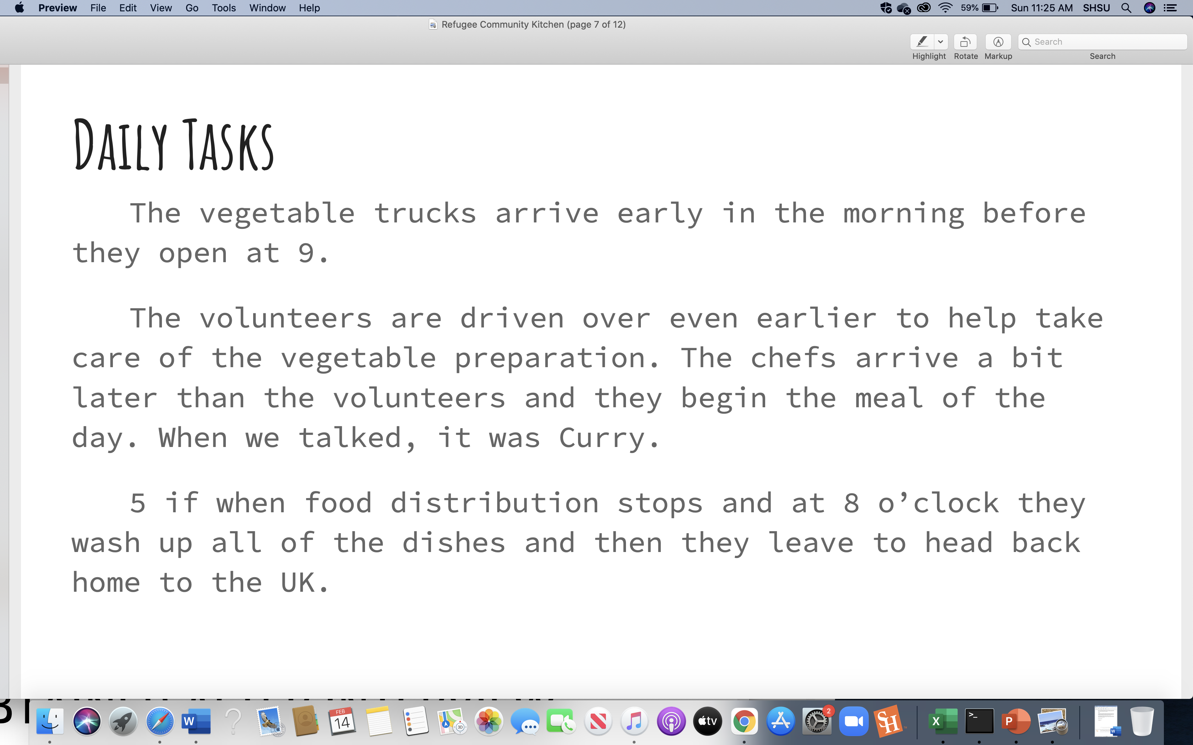
Note. General information about the tasks conducted by volunteers.

Sample 4
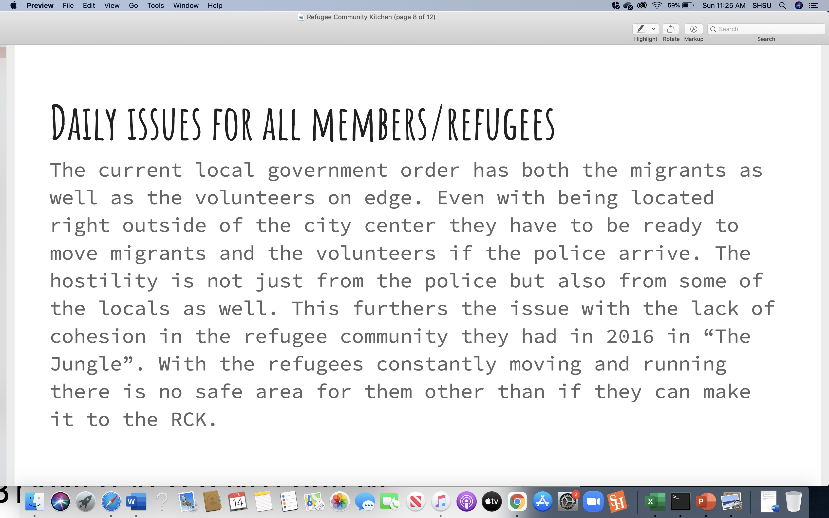
Note. Further information discussed by a volunteer worker in the Calais Jungle.

The students who researched the Calais Kitchen expressed a great deal of learning about migrant issues through their personal interviews with the volunteers. As the professor facilitating this project, I knew the information was accurate because I conducted my research in the Calais Jungle and I experienced similar situations and events. So, indeed I knew from my experiences that the information they gained from the interview was not misleading.
The next example illustrates a few of the sequential processes of communications that students experienced with a migrant solidarity group “Refugee Rights Europe.” This student group started with a migrant solidarity group “No Kids in Cages” and they learned from the social media site, however, they had to select another group to study because of the lack of relationship building, and after a critical analysis they learned that perhaps it was not a legitimate group. Accordingly, they also learned that some unofficial groups may not be active humanitarian organizations and may contribute to propaganda or bias viewpoints. Also, they learned the dynamics of volunteers in social media groups which makes communications limited as well. Furthermore, with “Refugee Rights Europe” which is an official humanitarian organization, students engaged in interviews with volunteers. The following samples showed a snapshot of the processes of communications that the students conducted. Students expressed that it took them a couple of months of formal e-mails and informal social media messages to develop relations and set an interview.

Sample 5
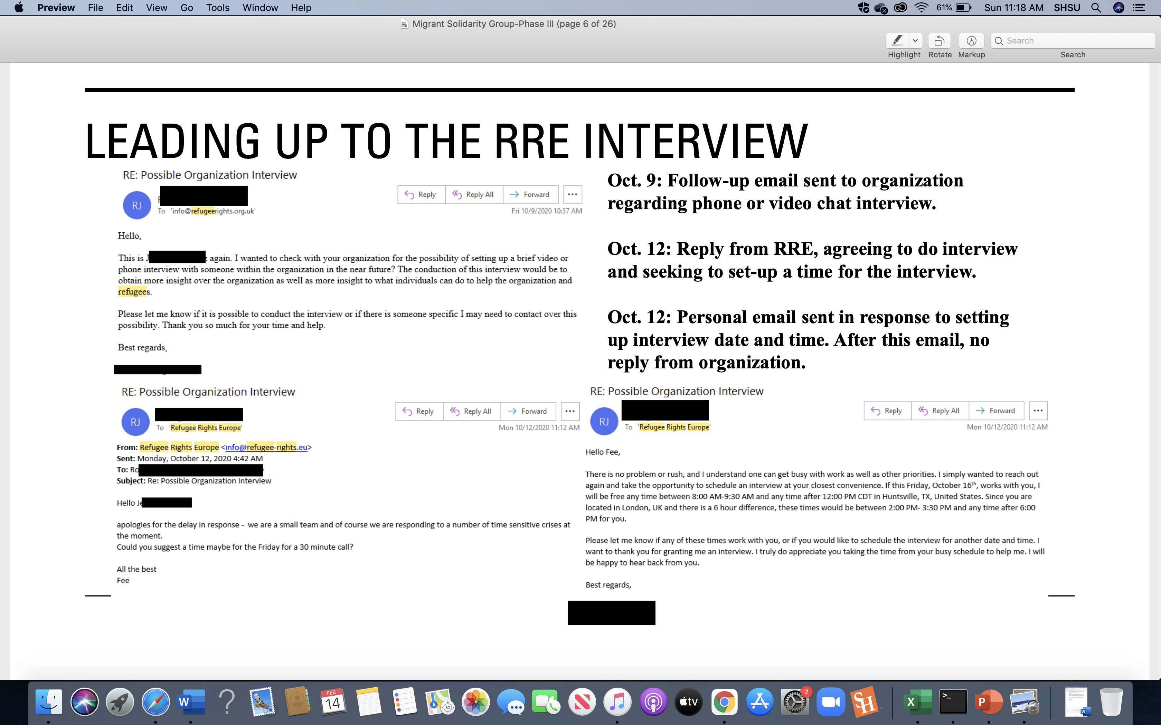
Note. First correspondences that students conducted in formal e-mails to the Refugee Rights Europe organization.

Sample 6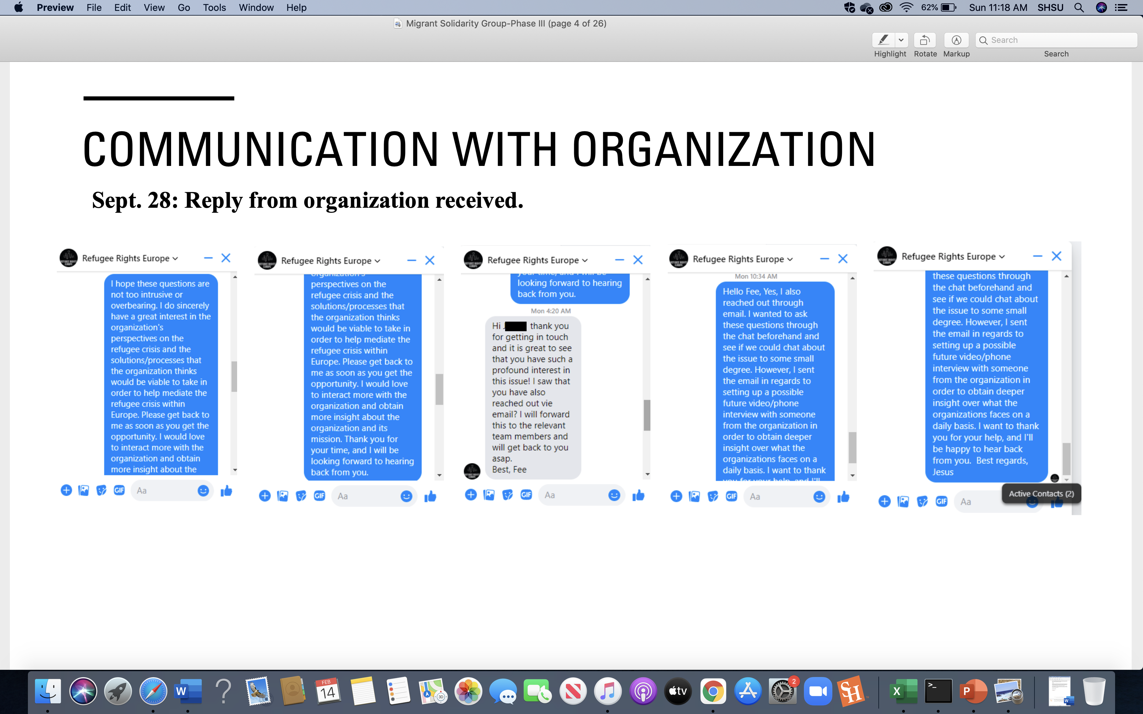Note. The grey message box illustrates a response from an organization member.

Sample 7
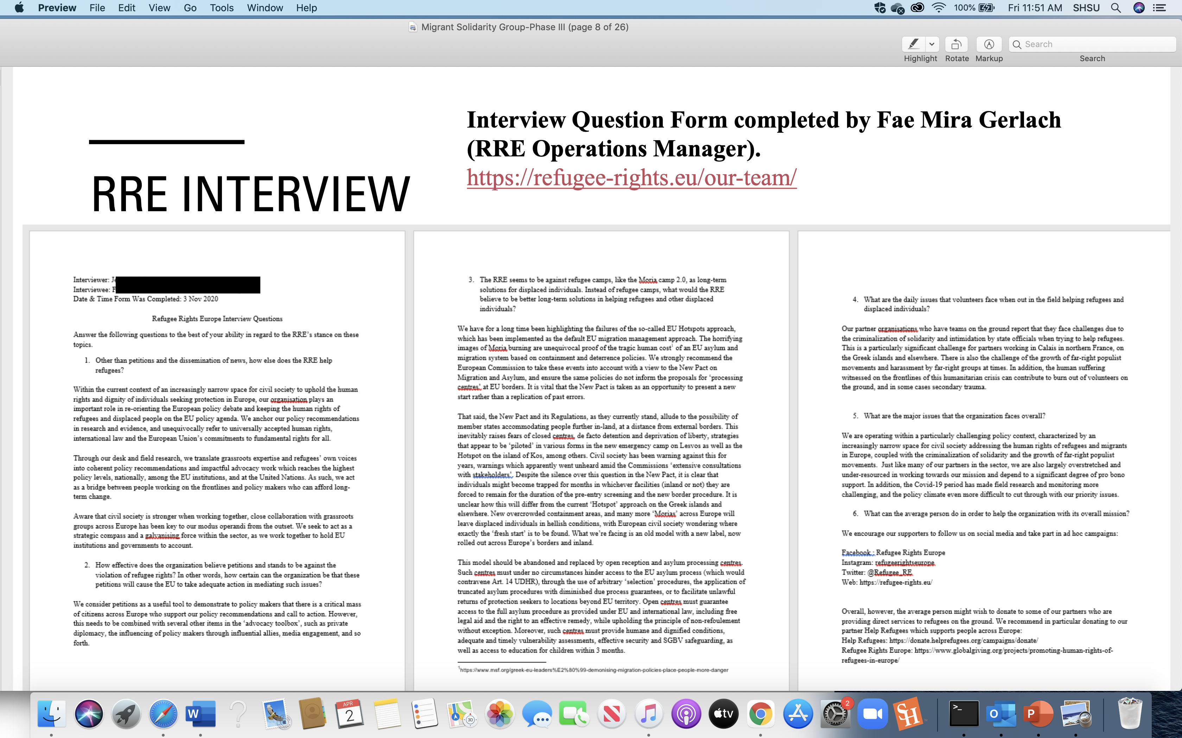
Note. On November 3, 2020, students conducted a formal written interview with a
volunteer of Refugee Rights Europe.

Sample 8
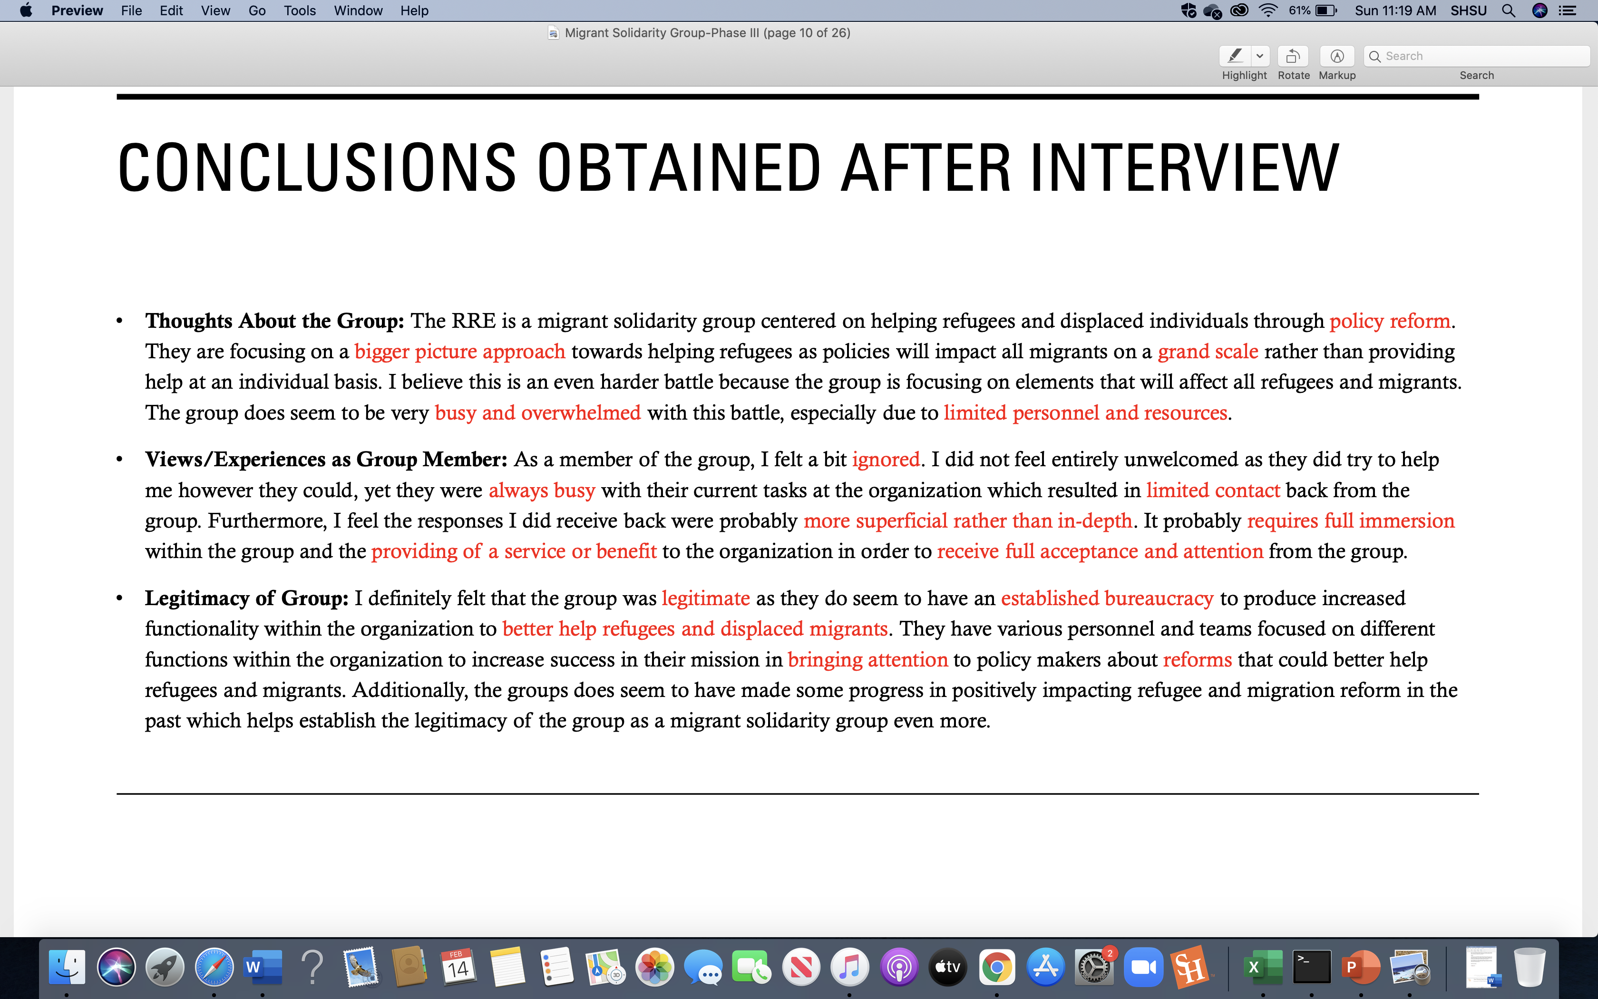
Note. Concluding remarks about the interview and research.

With this project students learned the perspectives of the “Refugee Rights Europe” humanitarian organization and that it was centered on policy reform. They learned that larger organizations developed partnerships with governing systems and their legitimacy as a humanitarian organization was centered on established bureaucracy. In this sense, ethnographic information related to the daily lives of volunteers and migrants was not within their framework to discuss for this organization. However, the research experiences of contacting official and unofficial organizations and interviewing members of the organizations; engaged students in an embodied experience that allowed them to be active agents within the humanitarian arena and provided them a glimpse into migrant processes.
Furthermore, the migrant solidarity project created a transformative learning experience for the students because it engaged them in the processes of refugees and migrants through an online and virtual communications. They learned from the people inside the organizations that help migrants. The students who could not obtain an interview also learned about the organizations and conditions of migrants worldwide, which provided a glimpse into the effects of the governance of migration at a global scale. Additionally, the universality of education was accomplished because students established knowledge from global sources within an online and virtual setting.
Virtual Learning Environment and Zoom as a Medium
For many undergraduate students virtual learning platforms may feel like an isolating experience. Indeed, students who register for a face-to-face seminar classes would expect a traditional learning setting inside the classroom sitting alongside the professor and fellow classmates. During the Covid-19 pandemic, face-to-face was improvised by blended and hybrid classes, and for some fully virtual. In the case of this honors class, which was intended to be a fully traditional seminar with the enrichment of field studies, the Covid-19 pandemic forced me to accommodate fully to virtual Zoom seminar mode. Indeed, the first few weeks were challenging in the sense that as a professor we had to connect with our students and help them to feel comfortable with the situation of virtual learning. The first challenge was technical and related to emulating a face-to-face discussion course. In this sense, some students felt that they did not need to turn on their cameras. Indeed, I found this quite non-educational, and I had to address this issue with sensitivity due to the pandemic stress. Once I addressed the fact that the class was face-to-face, and the format was an honors dialogue course; it was imperative to turn on the cameras to participate in an intellectually stimulating class. Indeed, upon this request in that manner all the students activated their cameras for the entirety of the semester. Also, with the reconciliation of the pandemic, health, and the idea that one could enjoy a class with all the comforts of home, everyone felt relaxed to open dialogue and participate equally in class. Additionally, the Zoom platform provided tools to express academic information just as one would observe in a traditional face-to-face classroom. As indicated in the aforementioned sections, Zoom is a medium of universality of education because it is inclusive to vulnerable and international populations. Incorporating guest speakers from different nationalities to discuss migrant issues was a success in this course.
Furthermore, according to Hall, proxemics plays a role in behavioral effects. In relation to the classroom the student/teacher proxemics are positioned as at the public speaking distance, somewhat distant from one another. The teacher speaks and reacts to the students from a distance, and they do not experience the casual interpersonal reactions of the students. In this sense, with the medium of Zoom, I noticed the benefits of interpersonal effects because students and teachers were visually in close proximity from one another. Indeed, one could see subtle facial reactions, which is not prominent in a classroom setting because the professor is often standing in the front of the classroom. Also, in seminar settings wherein students and the teacher are sitting at a round table, the proxemics although are close-up an in person, it is not representative of extreme close-up of the face. With extreme close-ups facial gestures are more prominent in the Zoom platform and this plays an important role in how the dynamics and interactions of the individuals perform their dialogues. I found the intrusion of extreme close-ups as effective at a motivational level because once individuals became acquainted with their close-up on camera, they were more animated and likely to present their expressions rather shying away from the weekly discussions. As a professor, I could see their expressions more clearly which helped me to facilitate the development of intergroup dialogue and I think this is a benefit of using Zoom. However, the interpersonal proxemics fails when the screen is shared and the gallery view no longer shows all of the participants, rather participants are viewed in a side bar either on the right or left of top or bottom. This occurs when participants or the host shares visual information on the screen. With this, the details of reactions become nil, yet the sharing of visual and aural information is beneficial to creating an inclusive class structure.
In conclusion, the integration of reading materials, guest speakers from the camps, visual materials, ethnographic research, and deliberative dialogues have established a global universality of education through its transformative experience. Students began the course with personal reflections and preconceptions of migrant topics, they learned dialogue through advancing their language and knowledge through text, and they engaged in in-person dialogue at an international level with guest speakers and humanitarian organizations. The medium of Zoom and online learning environments provided the tools to support global universal learning experiences.
For further research I would like to teach this course, yet with an addition to engage students in assisting refugees with resettlement organizations in Houston. The embodied experience is vital in learning processes with the integration of online settings as well. Also, further research is needed in relation to proxemics and intergroup dialogue using online platforms.

References

Anand, B., Man, K. A., Gajanan, N.P., & Manson, F. (2020). Zooming past the coronavirus lockdown: online spirometry practical demonstration with student involvement in analysis by remote control. Advances in Physiology Education 44(4) 516-519.
Bishop-Monroe, R. (2020). Reflections, challenges, and strategies for online academic instruction: a faculty perspective on rapid transition from face-to-face to online instruction during the Covid-19 crisis. Online Journal of distance learning administration, 23(23). Retrieved from https://www.westga.edu/~distance/ojdla/winter234/monroe234.html
Bodon, J. (1998). Cinema: An Introduction. U.S: McGraw-Hill
Bodon, J. (2019) 5096: Our Camp of Shame. [Documentary: Theatrical Release] Paris, France: Le Cinema, Le Studio.
Bodon, T. & Votteler, K. (2017). The Pedagogical Needs of Children and Adults Living in the Calais Jungle Refugee Camp: Existential Issues and Perspective of Volunteer Teacher and Workers. Forum for International Research Education,
4 (1), 113-138.
Boochani, B. (2018). No Friend But The Mountains. Canada and U.S.: ANASI International.
Chomsky, A. (2014). Undocumented: How Immigration Became Illegal. Boston, Massachusetts: Beacon Press.
David, M. (2017). Rescue: Refugees and the Political Crisis of Our Time. New York, N.Y: TED Books Simon & Schuster.
Davidson, J. & Hester Parr (2016). Enabling Cultures of Dis/order Online. In Chaouinard, V., Hall, E., & Wilton, R. (Eds.), Towards Enabling Geographies ‘Disabled’ Bodies and Minds in Society and Space (pp. 63-83). New York, NY: Routledge.
Freire, P. (2016). Education for Critical Conscious (4th ed.). Bloomsbury Academic. (Original book published 1974)
Ferrara, A. (2018). American Like Me: Reflections on Life Between Cultures. New York, N.Y: Gallery Books.
Ferris, E.G. & Donato, K.M. (2020). Refugees, Migration, and Global Governance: Negotiating the Global Compacts. New York, N.Y: Routledge.
Godin, M., Hansen, K.M., Lounasmaa, A., Squire, C., Zaman, & Tahir (2017). Voices From The ‘Jungle’: Stories from the Calais Refugee Camp. London, U.K: Pluto Press.
Gopal, N. Teaching revolution: A change to teaching and learning at UKZN has been fast-tracked by Covid-19. (2020, June 24) Witness (The South Africa). Retrieved from https://ndabaonline.ukzn.ac.za/UkzndabaStory/Vol8-Issue28/UKZNs%20New%20Pedagogy%20Facilitated%20through%20Online%20Learning/
Hall, T. E., (1990). The Silent Language. Anchor Book. (Original work published 1959).
Jamal, N.A.K., Ababneh, N., Hamid, Y., & Gawanmeh, A. (2021). Evaluating the effectiveness of distance learning in higher education during COVID-19 global crisis: UAE educator’s perspectives. Contemporary Educational Technology, 13(3). doi https://doi.org/10.30935/cedtech/10945
Maxwell, K.E., Nagda, B.A., and Thompson, M.C. (2011). Facilitating Intergroup Dialogues. Sterling, Virginia: Stylus.
Nguyen, C.T. (2021, March 12). Zoom classes felt like teaching into a void-unitl I told my students why. The Washington Post. Retrieved from https://www.washingtonpost.com/outlook/zoom-classes-felt-like-teaching-into-a-void--until-i-told-my-students-why/2021/03/11/024afb2c-81e5-11eb-81db-b02f0398f49a_story.html
Ohnigan, S., Richards, B.J., Monette, L.D., & Roberts, H.D. (2021). Optimizing remote learning: Leveraging zoom to develop and implement successful education sessions. Journal of Medical and Curricular Development, 8. Retrieved from https://www.ncbi.nlm.nih.gov/pmc/articles/PMC8243086/#idm139647214339744title
Spradley, J.P. (1979). The Ethnographic Interview. New York, N.Y: Holt, Rinehart, Winston.
Weydeman, J. D. & Weydeman, D. (Producers), & Pruess, J. (Director). (2019).
When Paul Came Over The Sea. Germany: Weydeman Bros.

